## Visoka skola strukovnih studija za informacione i komunikacione tehnologije

**Discover Universe**

<https://zarke998.github.io/discover-universe>

## Smer: Internet tehnologije Modul: Web programiranje Predmet: Web programiranje 1

Andrej Zarkovski 22/18

**Sadržaj**

1.Uvod.................................................................................................................................. 3

**Korišćeni programski jezici** 3

**Opis funkcionalnosti** 3

2.Organizacija 5

**Organizaciona šema** 5

**Mapa sajta** 6

**Opis stranica sajta** 7

Index.html 7

news.html 16

wallpapers.html 19

forum.html 21

about.html 28

3. Kodovi 30

HTML 30

index.html 30

news.html 34

wallpapers.html 37

forum.html 39

about.html 42

CSS 45

style.scss 45

style.css 59

JAVASCRIPT 74

main.js 74

news.js 81

wallpapers.js 86

forum.js 88

about.js 92

# Uvod

## **Korišćeni programski jezici**

Za izradu sajta korišćene su sledeće tehnologije:

* + - HTML 5
    - CSS 3/ SASS
    - Materialize
    - Bootstrap
    - JavaScript
    - jQuery
    - jQuery plugin – Animate Scroll
    - Visual Studio Code
    - Photoshop

## **Opis funkcionalnosti**

Sajt poseduje sledeće funkcionalnosti:

* Slide fade in efekat za naslov i tekst ispod naslova na stranici index
* Isprogramiran slajder na stranici index sa strelicama za menjanje slike uz fade out/fade in (crossfade efekat)
* Po ucitavanju stranice, slike za slajder se, osim prve koja se ucitava preko html src atributa za img tag, ucitavaju (preload-uju) preko javascripta kako bi se omogucila neometana tranzicija izmedju slika
* Countdown tajmer kod sekcije Meteor Rain na stranici index
* Generisanje zvezdica sa treptucim efektom na nasumicnim pozicijama kod sekcije Supernova na index stranici
* Pojavljivanje fiksne strelice kad se dodje pri dnu stranice koja vodi na pocetak (index.html)
* Dinamicko ispisivanje vesti na stranici news.html i podela njihovog ispisivanja po stranicama liste
* Dinamicko ispisivanje liste Events (news.html)
* Dinamicko ispisvanje slika na stranici Wallpapers uz to da kad se skroluje do kraja liste, ucitavaju jos slike ako ih ima
* Validacija elemenata forme za Login i Register deo na stranci Forum, s tim sto se validacija za Login deo vrsi u odnosu na upisane podatke u formi Register (tj. ti podaci se cuvaju u LocalStorage, pa se proveravaju za Login formu)

# Organizacija

## **Organizaciona šema**

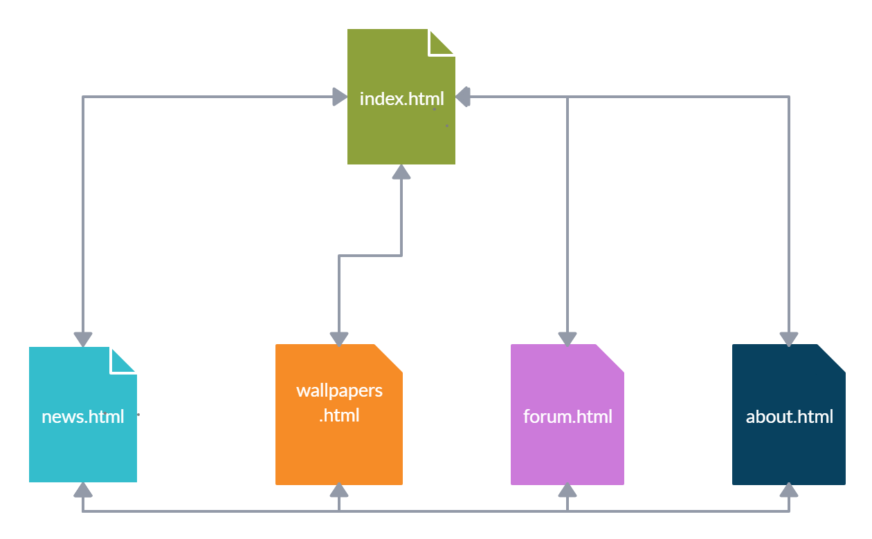

## **Mapa sajta**

<?xml version="1.0" encoding="UTF-8"?>

<urlset

      xmlns="http://www.sitemaps.org/schemas/sitemap/0.9"

      xmlns:xsi="http://www.w3.org/2001/XMLSchema-instance"

      xsi:schemaLocation="http://www.sitemaps.org/schemas/sitemap/0.9

            http://www.sitemaps.org/schemas/sitemap/0.9/sitemap.xsd">

<url>

  <loc>https://zarke998.github.io/discover-universe/index.html</loc>

  <lastmod>2019-12-06T12:27:13+00:00</lastmod>

  <changefreq>daily</changefreq>

  <priority>1.00</priority>

</url>

<url>

  <loc>https://zarke998.github.io/discover-universe/news.html</loc>

  <lastmod>2019-12-06T12:27:13+00:00</lastmod>

  <changefreq>daily</changefreq>

  <priority>0.90</priority>

</url>

<url>

  <loc>https://zarke998.github.io/discover-universe/wallpapers.html</loc>

  <lastmod>2019-12-06T12:27:13+00:00</lastmod>

  <changefreq>weekly</changefreq>

  <priority>0.80</priority>

</url>

<url>

  <loc>https://zarke998.github.io/discover-universe/forum.html</loc>

  <lastmod>2019-12-06T12:27:13+00:00</lastmod>

  <changefreq>weekly</changefreq>

  <priority>0.80</priority>

</url>

<url>

  <loc>https://zarke998.github.io/discover-universe/about.html</loc>

  <lastmod>2019-12-06T12:27:13+00:00</lastmod>

  <changefreq>yearly</changefreq>

  <priority>0.60</priority>

</url>

</urlset>

## **Opis stranica sajta**

### Index.html

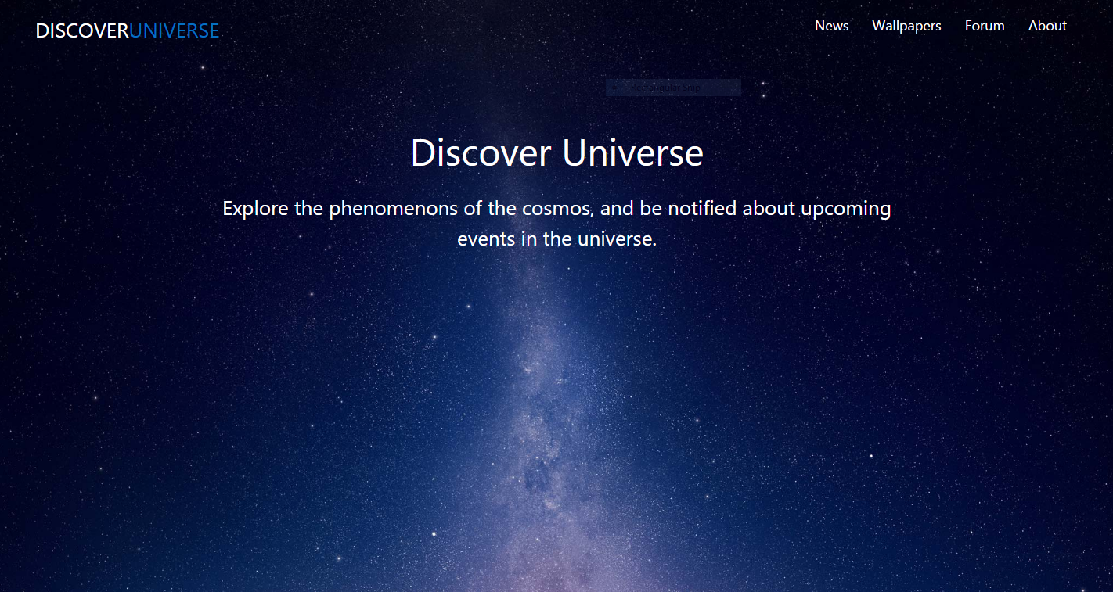

Po ucitavanju stranice izvrsi se animacija fade in preko jQuery-ja, i animira se pozicija naslova »Discover Universe« i teksta ispod njega.

-Nav meni je preuzet iz materialize-a i nalazi se na svim ostalim stranicama.

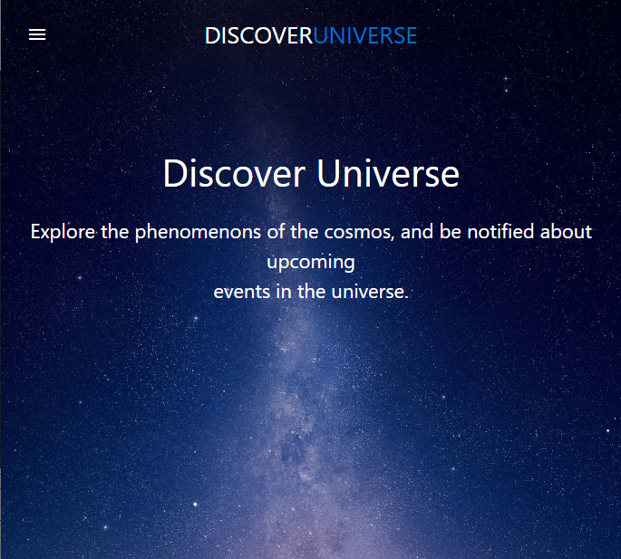

Takodje se pri smanjivanju velicine ekrana pojavljuje hamburger koji kad se klikne izbacuje sidenav iz Materialize-a kao na slici ispod.

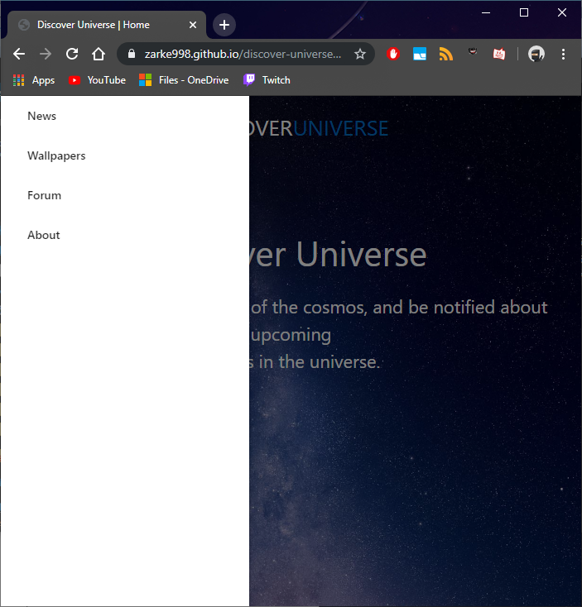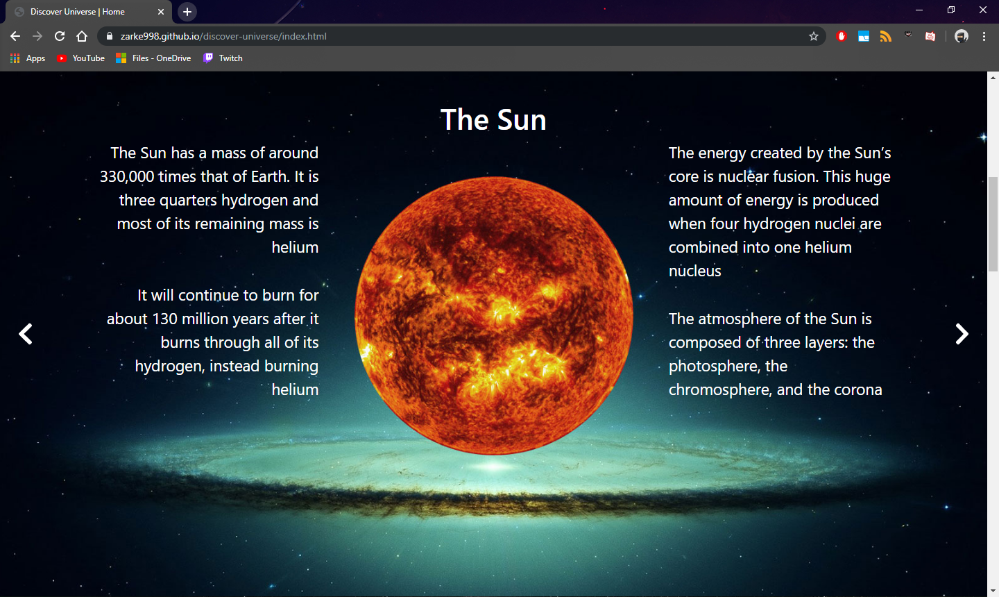

Odmah posle uvodnog dela index.html stranice, nalazi se slajder, cije su animacije kao i dugmici za pomeranje slike slajdera isprogramirani preko javascripta.

Klikom na strelice vrsi se fade in/fade out (crossfade) animacija.

Takodje su naslov slike, slika kao i tekst za opis slike dinamicki generisani.

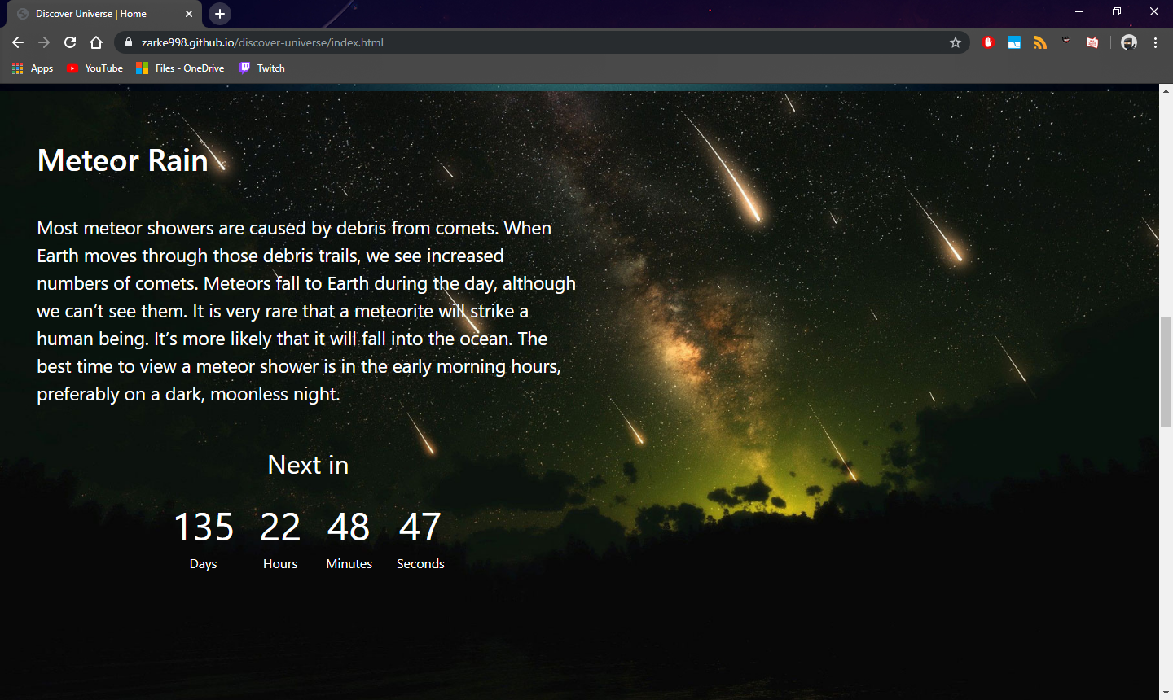

Na sekciji Meteor Rain nalazi se tekst za opis ove pojave, kao i tajmer koji odbrojava do sledeceg pojavljivanja ovog fenomena na nebu.

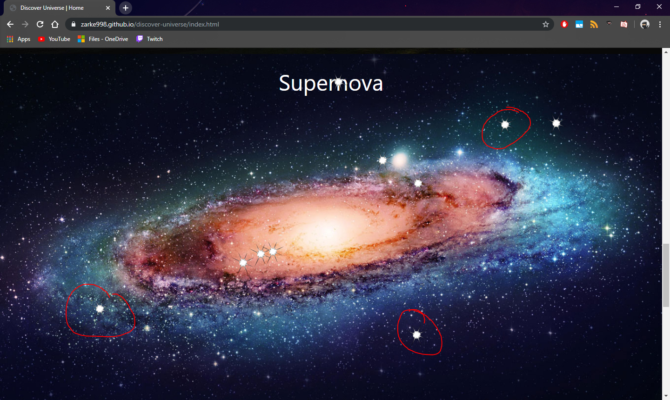

Posle sekcije Meteor Rain, dolazi se do sekcije Supernova.

Ovde se nalazi inicjalno samo pozadina, nakon cega se javascriptom generisu elementi zvezdice (na slici crvenim) koje imaju animaciju da prelaze iz nesvetleceg stanja u svetlece.

One se generisu na nasumicnim pozicijama i klikom na njih se odmah pored pojavljuje popup prozorcic kao na slici ispod.

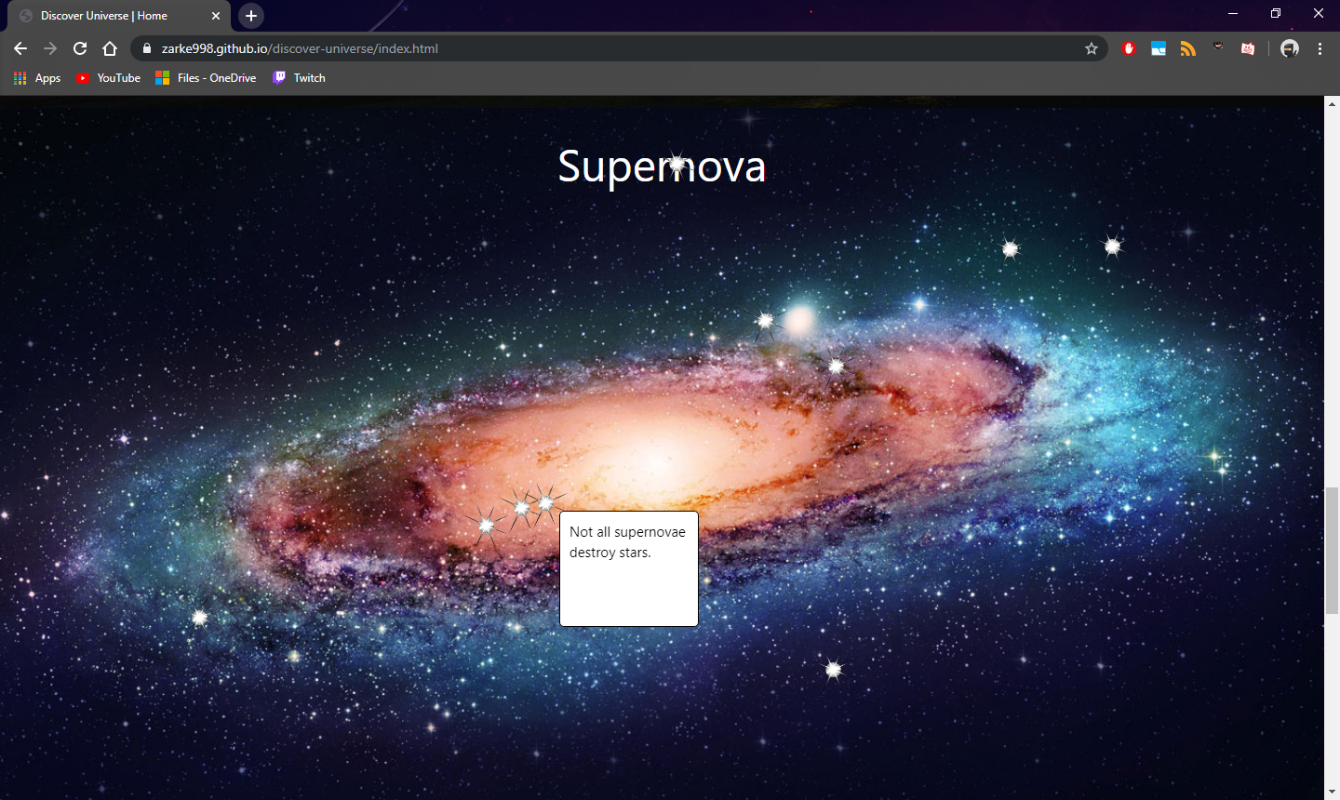

Takodje se prilikom resizovanja browsera, generisu nove pozicije za zvezdice, kako ne bi izlazile van okvira prozora.

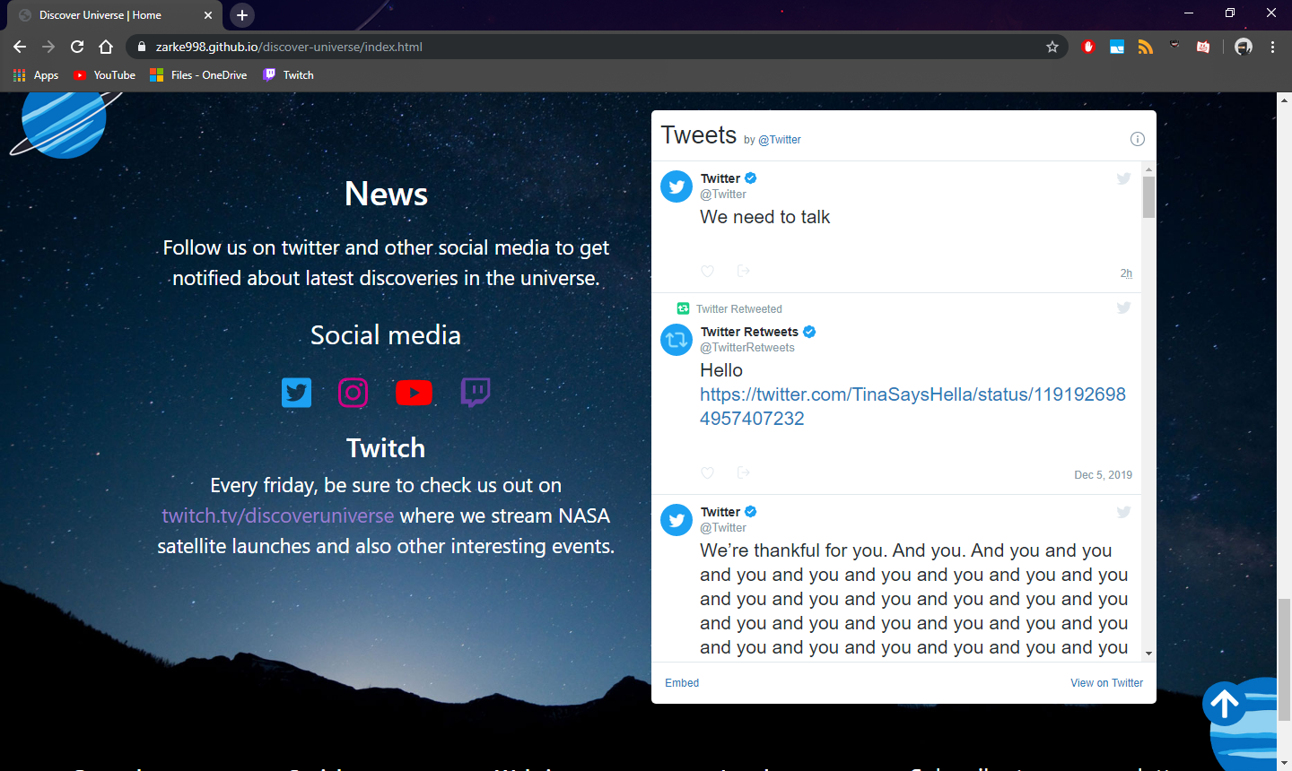

Kod news sekcije, nalaze se linkovi ka socijalnim mrezama, kao i embedovan iframe od twitter-a.

Pri dolasku do dna stranice (news sekcije), u donjem desnom uglu se pojavljuje link u vidu strelice, na ciji se klik poziva **jQuery plugin** – Animate scroll, koji vraca viewport na vrh stranice uz postavljenu animaciju.

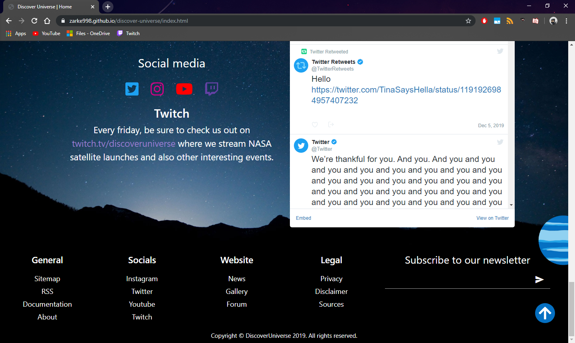

Na samom dnu stranice nalazi se footer, koji u sebi sadrzi informacione fajlove o sajtu, linkove ka socijalnim mrezama, linkove ka ostalim stranicama istog sajta, i podsekciju Legal za pravne dokumente.

Takodje se nalazi i polje upis email-a za pretplatu na novinske clanke ovog sajta.

Ovaj footer se nalazi na svim ostalim stranicama.

### news.html

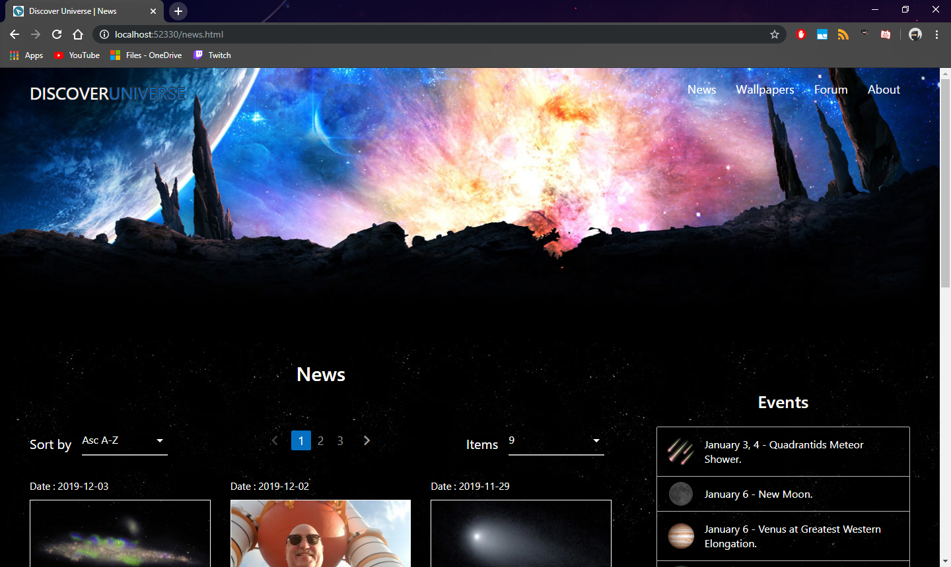

Izgled pocetnog dela news.html stranice.

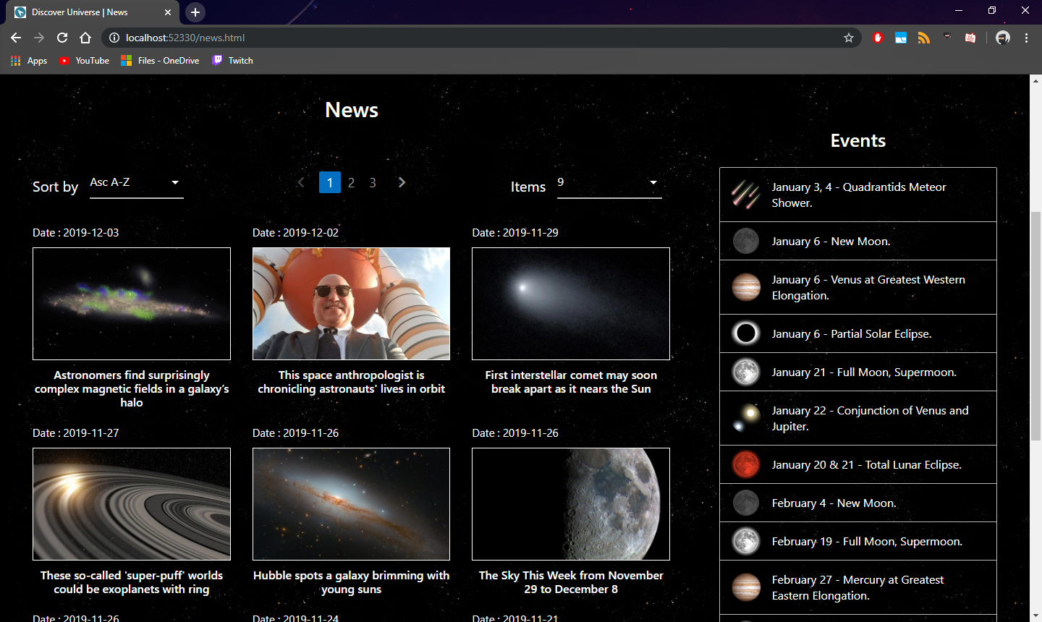

Ispod pocetnog dela nalazi se lista novinskih clanaka koja se dinamicki generise i ispisuje unutar div-a.

Odmah ispod imena list »News« , kao i na kraju liste, nalazi se navigacija liste u vidu stranica i strelica. Klikom na jedne od njih generisu se dinamicki nove clanci koji pripadaju drugoj strani, dok se trenutni brisu.

Inicijalno se clanci sortiraju po datumu u opadacujem redosledu(od skorijeg pa ranijeg) za koje je napravljena funkcija u javascriptu, koja moze da sortira u oba smera.

Takodje se dinamicki generisu stavke liste »Events«.

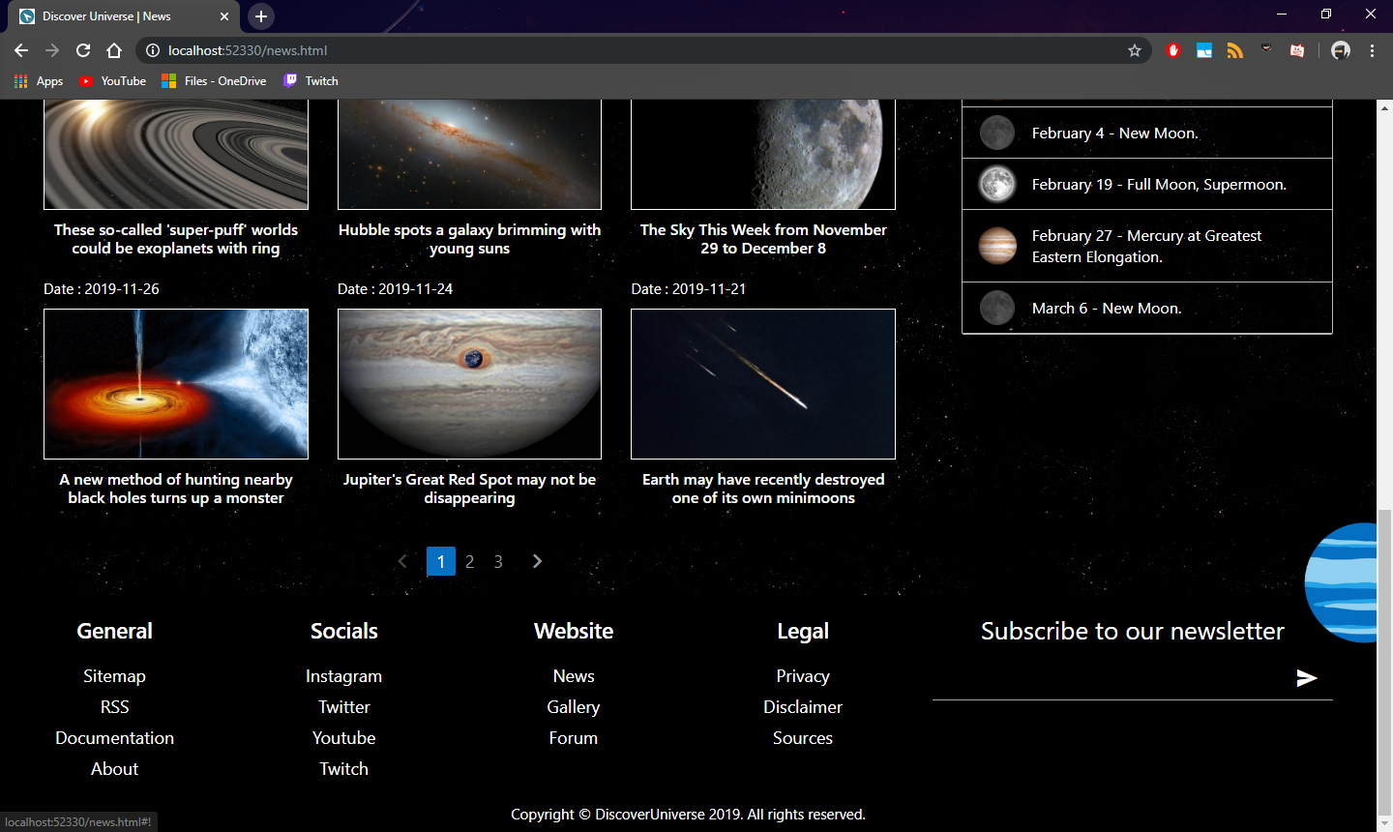

Izgled dna stranice news.html.

### wallpapers.html

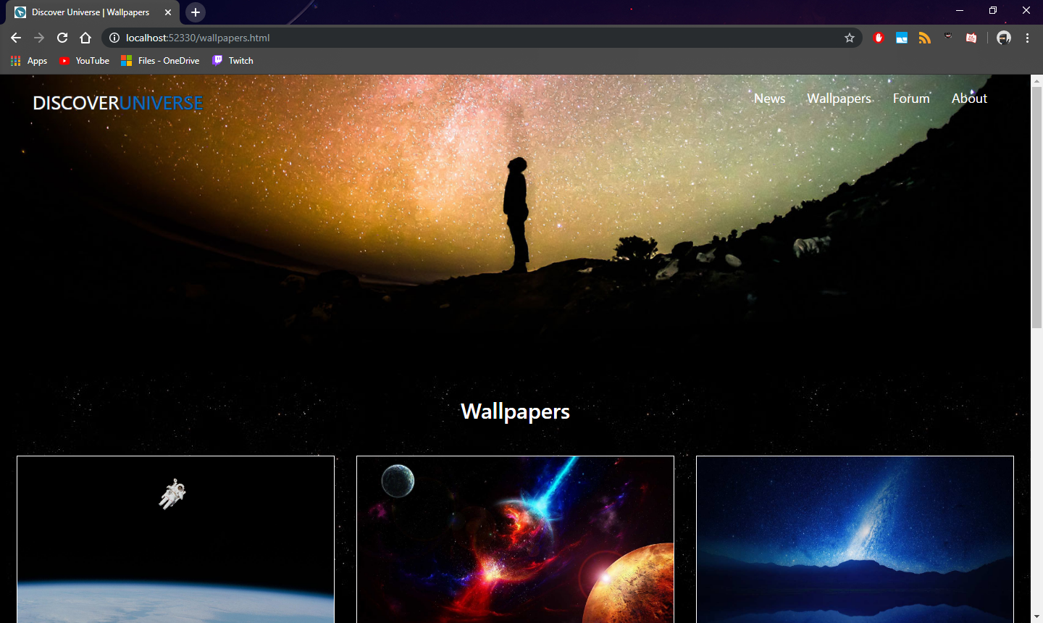

Izgled pocetnog dela stranice.

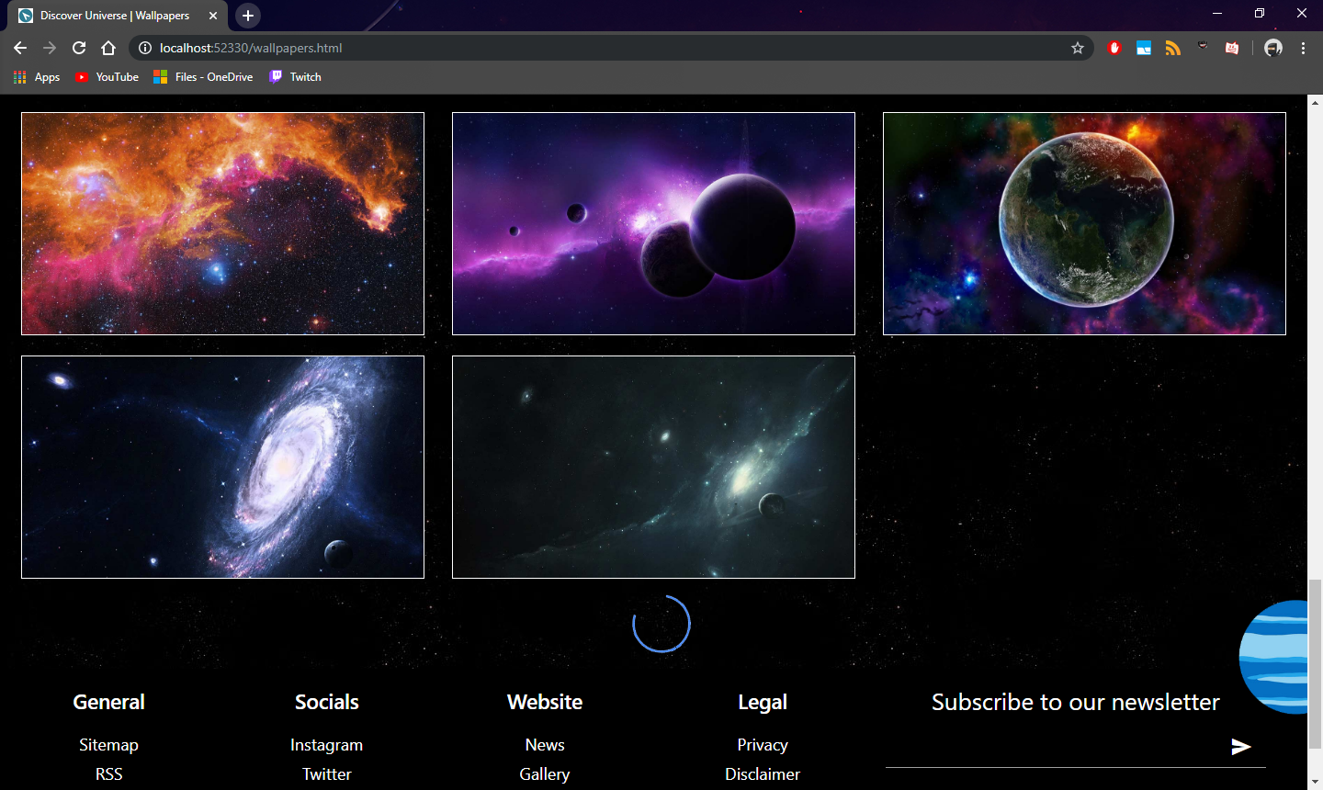

Pri dolasku na dno galerije, pojavljuje se loader element, pri cemu se nakon 1s ucitavaju slike ponovo dinamicki a on zatim nestaje.

### forum.html

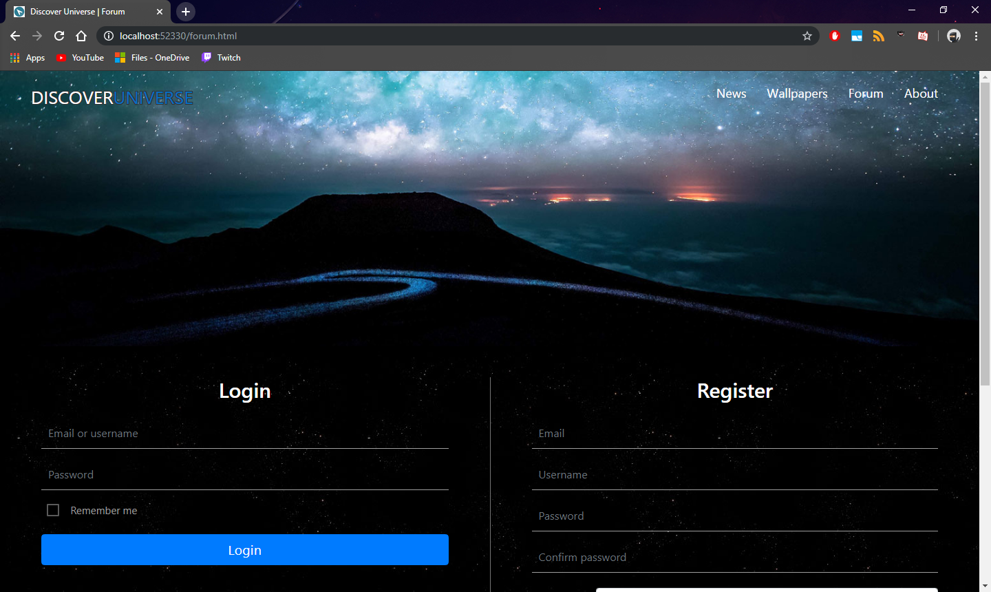

Izgled pocetnog dela stranice.

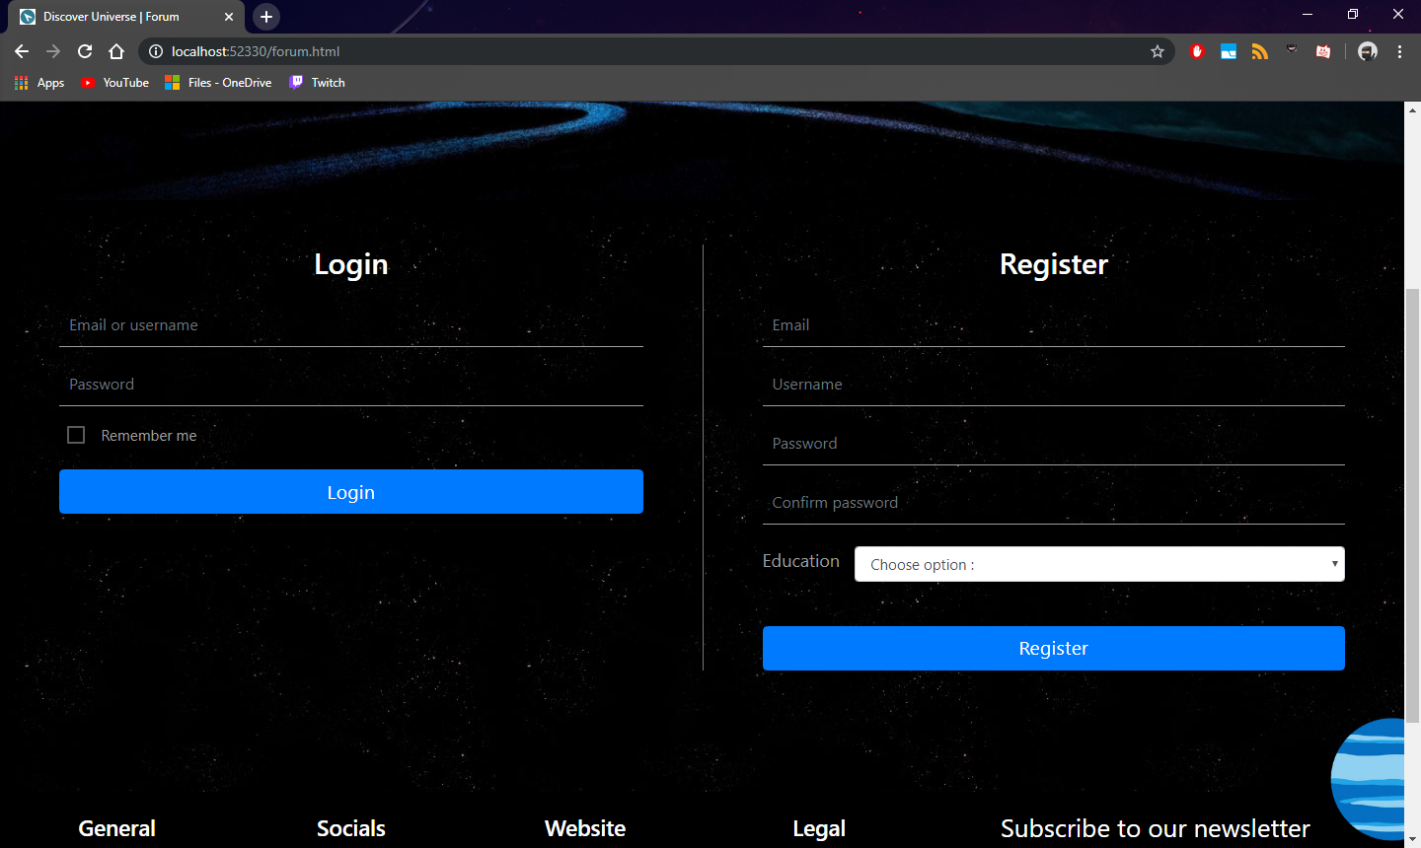

U glavnom delu stranice nalaze se dve kolone, jedna za logovanje, a druga za registraciju.

Elementi forme uzeti su iz framework-a Bootstrap.

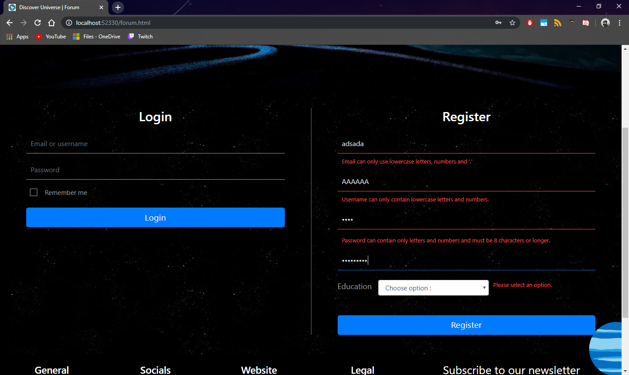

Klikom na dugme »Register«, polja forme se validiraju regularnim izrazima u Javascript-u. Ukoliko polja ne zadovoljavaju regularni izraz, njihov border dobija crvenu boju, a ispod njih se dinamicki ispisuje tekst crvene boje koji ukazuje na razlog neuspele validacije polja.

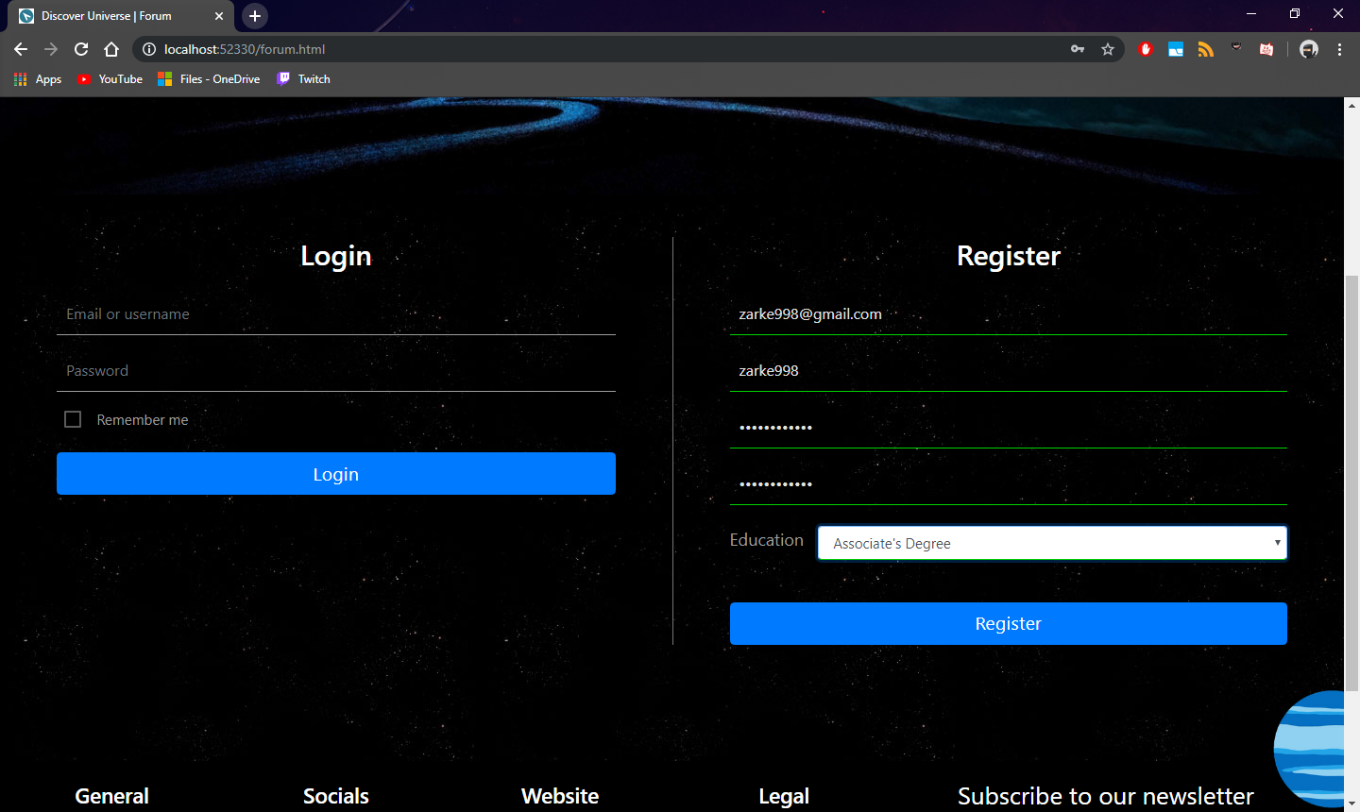

Ukoliko su sva polja validno uneta, njima se dodaje border zelene boje kao znak uspesne validacije.

Potom se vrednosti polja upisuju u LocalStorage, koja ce se kasnije koristiti za validaciju vorme »Login«.

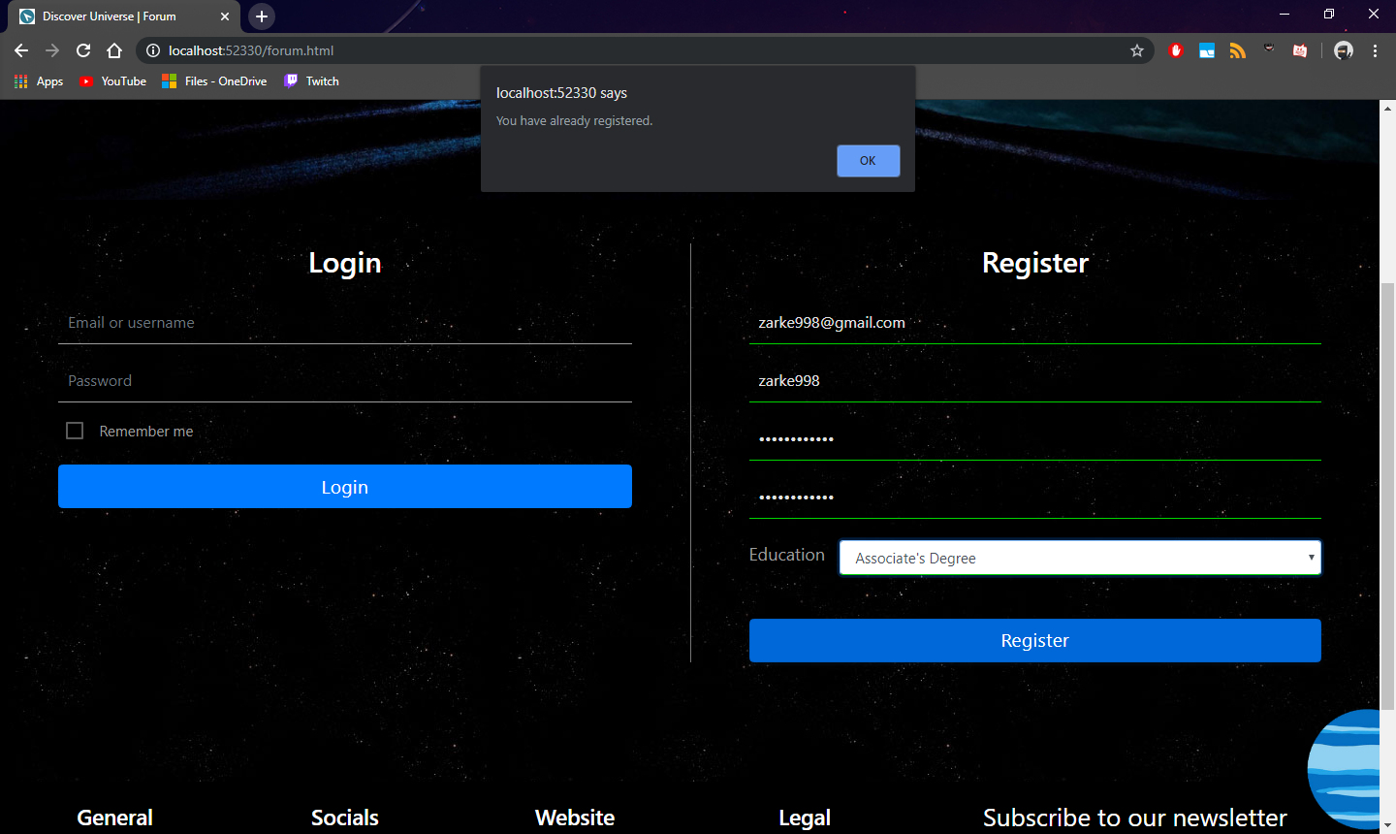

Ukoliko se ponovo unesu isti podaci za registraciju, izbacice se alert prozor koji obavestava da ste se vec registrovali.

Takodje, pri uspesnoj registraciji , izbacuje se slican prozor sa porukom »Registracija upsesna«.

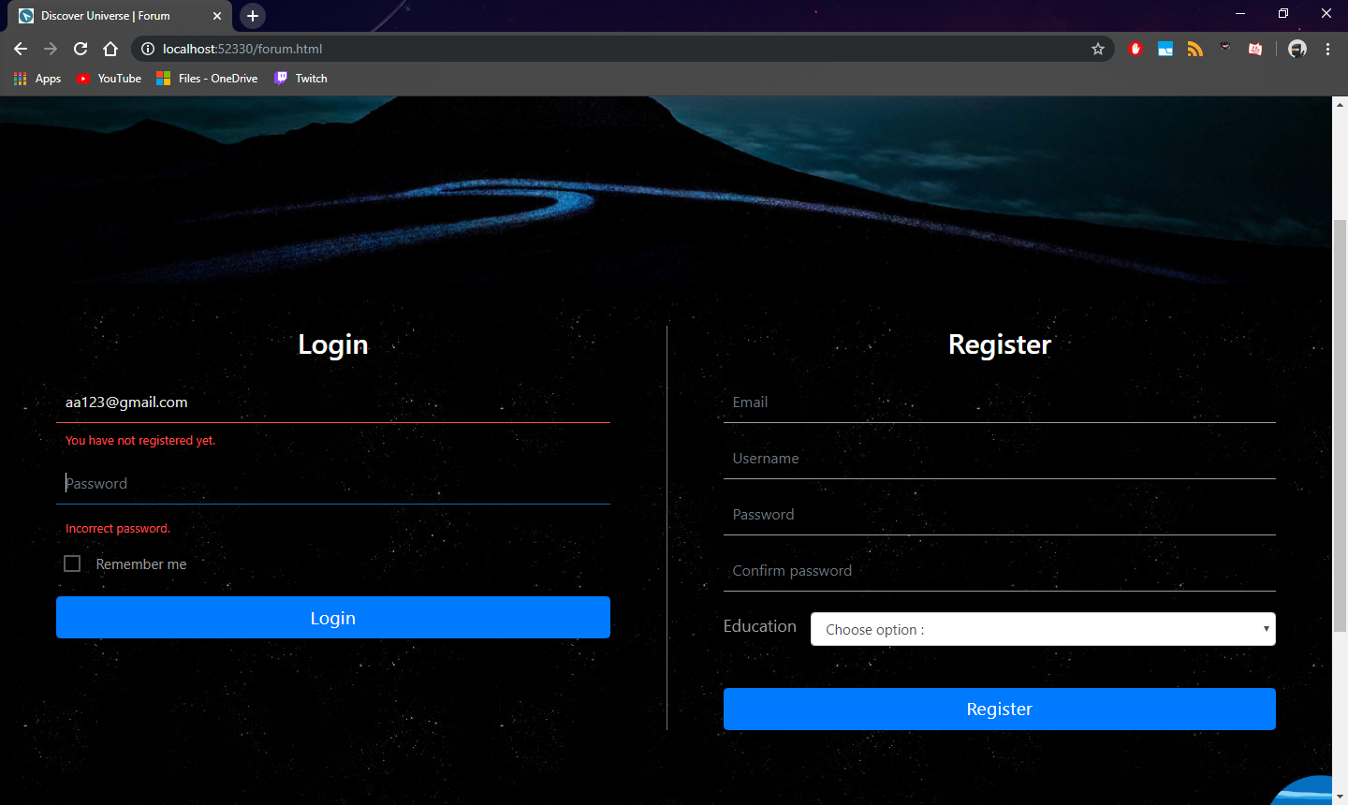

Ukoliko se u »Login« formu unesu podaci koji nisu registrovani u LocalStorage, ispod odgovarajucih polja ce se izbaciti poruka obojena crvenom bojom, a i sami elementi ce biti podvuceni crvenom bojom.

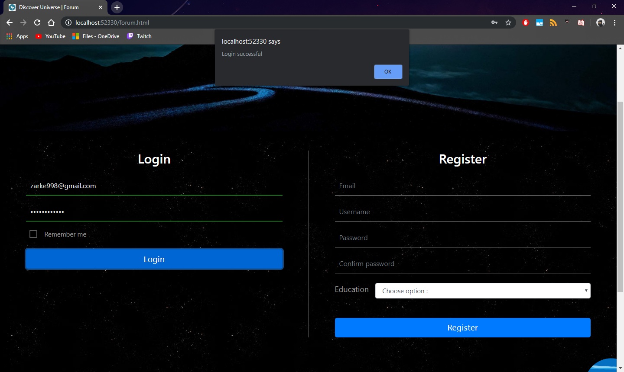

Pri uspesnoj registraciji polja se podvlace zelenom bojom i prikazuje se prozor sa porukom »Logovanje uspesno«.

### about.html

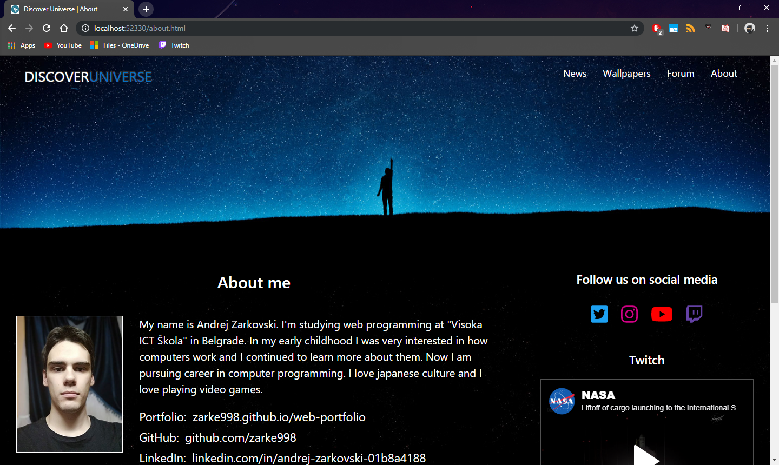

Pocetni izgled stranice.

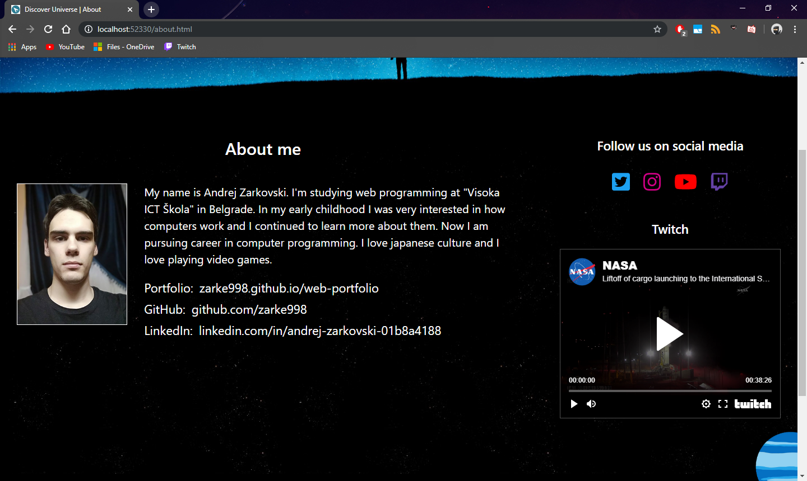

U glavnom delu stranice »O Autoru« nalazi se profilna slika sa kratkom biografiom, dok se sa strane nalaze linkovi ka socijalnim mrezma kao i embeded iframe Twitch platforme za strimovanje uzvio.

# 3. Kodovi

## HTML

### index.html

<!DOCTYPE html>

<html lang="en">

<head>

    <meta charset="UTF-8">

    <meta name="viewport" content="width=device-width, initial-scale=1.0">

    <meta http-equiv="X-UA-Compatible" content="ie=edge">

    <title>Discover Universe | Home</title>

    <link href="https://fonts.googleapis.com/icon?family=Material+Icons" rel="stylesheet">

    <link rel="stylesheet" type="text/css" href="css/materialize.css">

    <link rel="stylesheet" type="text/css" href="css/bootstrap.css">

    <link rel="stylesheet" type="text/css" href="css/style.css">

    <script defer src="js/font-awesome.js"></script>

</head>

<body>

    <div id="homeIntro" class="fullscreen">

        <nav id="navBar" class="container-fluid px-5">

            <div class="nav-wrapper">

                <a id="logo" href="index.html" class="brand-logo">Discover<span>Universe</span></a>

                <a id="mobile-menu" href="#" data-target="mobile-demo" class="sidenav-trigger"><i

                        class="material-icons">menu</i></a>

                <ul id="nav-mobile" class="right hide-on-med-and-down">

                    <li class="element"><a href="news.html">News</a></li>

                    <li><a href="wallpapers.html">Wallpapers</a></li>

                    <li><a href="forum.html">Forum</a></li>

                    <li><a href="about.html">About</a></li>

                </ul>

            </div>

        </nav>

        <ul class="sidenav" id="mobile-demo">

            <li><a href="news.html">News</a></li>

            <li><a href="wallpapers.html">Wallpapers</a></li>

            <li><a href="forum.html">Forum</a></li>

            <li><a href="about.html">About</a></li>

        </ul>

        <div class="contianer-fluid">

            <div class="row mx-0">

                <div id="introHeadingText" class="col-12 text-center">

                    <h1 id="introHeadingTextMain">Discover Universe</h1>

                    <p>Explore the phenomenons of the cosmos, and be notified about upcoming <br>

                        events in the universe.

                    </p>

                </div>

            </div>

        </div>

    </div>

    <div id="sliderSection" class="fullscreen">

        <div id="solarSystemSlider" class="position-relative h-100">

            <div id="solar-slider-nav-left" data-incrementfor="-1"

                class="solar-slider-nav d-flex flex-column justify-content-center align-items-center">

                <i class="fas fa-chevron-left d-block solar-slider-nav-arrow"></i>

            </div>

            <div id="solar-slider-nav-right" data-incrementfor="1"

                class="solar-slider-nav d-flex flex-column justify-content-center align-items-center">

                <i class="fas fa-chevron-right d-block solar-slider-nav-arrow"></i>

            </div>

            <div id="solarSystemSliderText" class="d-flex flex-column justify-content-between">

                <div id="sliderTextWrapper" class="row mx-0">

                    <div class="col-12">

                        <h4 id="planetName" class="text-center">The sun</h4>

                    </div>

                    <div class="col-3 offset-1 text-right slider-text">

                        <p></p>

                        <p></p>

                    </div>

                    <div class="col-4"></div>

                    <div class="col-3 slider-text">

                        <p></p>

                        <p></p>

                    </div>

                </div>

                <div id="sliderMobileText">

                    <p class="text-center"></p>

                </div>

            </div>

        </div>

    </div>

    <div id="meteorSection" class="fullscreen pt-5 px-5">

        <h2 class="mb-5 mt-3">Meteor Rain</h2>

        <p class="mb-5">Most meteor showers are caused by debris from comets. When Earth moves through those debris

            trails, we see increased numbers of comets. Meteors fall to Earth during the day, although we can’t see

            them. It is very rare that a meteorite will strike a human being. It’s more likely that it will fall into

            the ocean. The best time to view a meteor shower is in the early morning hours, preferably on a dark,

            moonless night.</p>

        <div id="meteorTimerWrapper">

            <p class="text-center">Next in</p>

            <div id="meteorTimer" class="d-flex justify-content-center">

                <div id="meteorTimerDays" class="mx-3">

                    <p class="text-center"><span>122</span><br>Days</p>

                </div>

                <div id="meteorTimerHours" class="mx-3">

                    <p class="text-center"><span>12</span><br>Hours</p>

                </div>

                <div id="meteorTimerMinutes" class="mx-3">

                    <p class="text-center"><span>34</span><br>Minutes</p>

                </div>

                <div id="meteorTimerSeconds" class="mx-3">

                    <p class="text-center"><span>56</span><br>Seconds</p>

                </div>

            </div>

        </div>

    </div>

    <div id="supernovaSection" class="fullscreen position-relative">

        <p class="text-center pt-4">Supernova</p>

    </div>

    <div id="newsSection" class="fullscreen position-relative">

        <img src="images/uranus-icon.png" alt="Uranus">

        <div class="row mx-0 h-100 my-0">

            <div id="newsText" class="col-10 offset-1 col-md-5 offset-md-1 text-center mt-0 mt-md-5 pl-3 pl-md-5">

                <h2 class="mb-4 mt-4">News</h2>

                <p>Follow us on twitter and other social

                    media to get notified about latest

                    discoveries in the universe.

                </p>

                <p class="mt-4">Social media</p>

                <p>

                    <a href="#" class="socials"><i class="fab fa-twitter-square"></i></a>

                    <a href="#" class="socials"><i class="fab fa-instagram"></i></a>

                    <a href="#" class="socials"><i class="fab fa-youtube"></i></a>

                    <a href="#" class="socials"><i class="fab fa-twitch"></i></a>

                </p>

                <h3 class="mt-3">Twitch</h3>

                <p>Every friday, be sure to check us out on <a href="#">twitch.tv/discoveruniverse</a> where we stream

                    NASA satellite launches and also other interesting events.</p>

            </div>

            <div id="twitterEmbed" class="col-10 offset-1 col-md-5 offset-md-0 pb-5">

                <a class="twitter-timeline" data-height="500" data-theme="light"

                    href="https://twitter.com/Twitter?ref_src=twsrc%5Etfw">Tweets by Twitter</a>

                <script id="twitterScript" src="https://platform.twitter.com/widgets.js" type="text/javascript"

                    charset="utf-8"></script>

                <!-- <iframe src="https://twitter.com"></iframe> -->

            </div>

        </div>

    </div>

    <div id="footer" class="text-center">

        <img src="images/neptune-icon.png" alt="Neptune icon">

        <div class="row mx-0 my-0">

            <div class="col-sm-6 col-md-2 mt-4">

                <h4>General</h4>

                <ul>

                    <li><a href="#">Sitemap</a></li>

                    <li><a href="#">RSS</a></li>

                    <li><a href="#">Documentation</a></li>

                    <li><a href="#">About</a></li>

                </ul>

            </div>

            <div class="col-sm-6 col-md-2 mt-4">

                <h4>Socials</h4>

                <ul>

                    <li><a href="#">Instagram</a></li>

                    <li><a href="#">Twitter</a></li>

                    <li><a href="#">Youtube</a></li>

                    <li><a href="#">Twitch</a></li>

                </ul>

            </div>

            <div class="col-sm-6 col-md-2 mt-4">

                <h4>Website</h4>

                <ul>

                    <li><a href="#">News</a></li>

                    <li><a href="#">Gallery</a></li>

                    <li><a href="#">Forum</a></li>

                </ul>

            </div>

            <div class="col-sm-6 col-md-2 mt-4">

                <h4>Legal</h4>

                <ul>

                    <li><a href="#">Privacy</a></li>

                    <li><a href="#">Disclaimer</a></li>

                    <li><a href="#">Sources</a></li>

                </ul>

            </div>

            <div class="col-md-4 pr-md-5 mt-4">

                <p>Subscribe to our newsletter</p>

                <div>

                    <input type="text">

                    <a href="#"><i class="material-icons">send</i>

                    </a>

                </div>

            </div>

        </div>

        <p class="mb-0 py-2 px-4">Copyright © DiscoverUniverse 2019. All rights reserved.</p>

    </div>

    <div id="fixedButtonWrapper">

        <a id="fixedButton" href="#"><i class="fas fa-arrow-up"></i></a>

    </div>

    <script src="https://ajax.googleapis.com/ajax/libs/jquery/3.4.1/jquery.min.js" type="text/javascript"></script>

    <script src="js/materialize.js" type="text/javascript"></script>

    <script src="js/animatescroll.js" type="text/javascript"></script> <!-- jQuery plugin-->

    <script src="js/main.js"></script>

</body>

</html>

### news.html

<!DOCTYPE html>

<html lang="en">

<head>

    <meta charset="UTF-8">

    <meta name="viewport" content="width=device-width, initial-scale=1.0">

    <meta http-equiv="X-UA-Compatible" content="ie=edge">

    <title>Discover Universe | News</title>

    <link href="https://fonts.googleapis.com/icon?family=Material+Icons" rel="stylesheet">

    <link rel="stylesheet" type="text/css" href="css/materialize.css">

    <link rel="stylesheet" type="text/css" href="css/bootstrap.css">

    <link rel="stylesheet" type="text/css" href="css/style.css">

</head>

<body>

    <div id="newsIntro" class="shorterIntro">

        <nav id="navBar" class="container-fluid px-5">

            <div class="nav-wrapper">

                <a id="logo" href="index.html" class="brand-logo bolded-logo">Discover<span>Universe</span></a>

                <a id="mobile-menu" href="#" data-target="mobile-demo" class="sidenav-trigger"><i

                        class="material-icons">menu</i></a>

                <ul id="nav-mobile" class="right hide-on-med-and-down bolded-menu">

                    <li><a href="news.html">News</a></li>

                    <li><a href="wallpapers.html">Wallpapers</a></li>

                    <li><a href="forum.html">Forum</a></li>

                    <li><a href="about.html">About</a></li>

                </ul>

            </div>

        </nav>

        <ul class="sidenav" id="mobile-demo">

            <li><a href="news.html">News</a></li>

            <li><a href="wallpapers.html">Wallpapers</a></li>

            <li><a href="forum.html">Forum</a></li>

            <li><a href="about.html">About</a></li>

        </ul>

    </div>

    <div id="newsPageMain">

        <div class="row pt-5 mx-0 my-0">

            <div class="col-12 col-md-8 px-4 pl-md-5">

                <h2 class="text-center mb-5">News</h2>

                <div class="row mx-0">

                    <div class="col-sm-4 col-lg-3 px-0 mySelectWrapper order-2 order-sm-1">

                        <p>Sort by</p>

                        <div class="input-field col s12">

                            <select id="sortBy">

                                <option value="1">Asc A-Z</option>

                                <option value="2">Desc Z-A</option>

                                <option value="3">Date Asc</option>

                                <option value="4">Date Desc</option>

                            </select>

                        </div>

                    </div>

                    <div id="paginationWrapper" class="col-sm-4 col-lg-6 px-0 order-1 order-sm-2">

                        <ul class="pagination d-flex justify-content-center">

                            <li class="disabled" data-increment="-1"><a href="#!"><i

                                        class="material-icons">chevron_left</i></a></li>

                            <li class="active"><a href="#!">1</a></li>

                            <li class="waves-effect"><a href="#!">2</a></li>

                            <li class="waves-effect"><a href="#!">3</a></li>

                            <li class="waves-effect" data-increment="1"><a href="#!"><i

                                        class="material-icons">chevron_right</i></a></li>

                        </ul>

                    </div>

                    <div class="col-sm-4 col-lg-3 px-0 mySelectWrapper order-3 order-sm-3">

                        <p>Items</p>

                        <div class="input-field col s12">

                            <select id="itemsShowing">

                                <option value="9">9</option>

                                <option value="12">12</option>

                                <option value="15">15</option>

                            </select>

                        </div>

                    </div>

                </div>

                <div id="newsList" class="row"></div>

                <div class="row mx-0">

                    <div id="paginationWrapper" class="col-sm-4 col-lg-6 offset-0 offset-sm-4 offset-lg-3 px-0">

                        <ul class="pagination d-flex justify-content-center">

                            <li class="arrow disabled" data-increment="-1"><a href="#!"><i

                                        class="material-icons">chevron_left</i></a></li>

                            <li class="active"><a href="#!">1</a></li>

                            <li class="waves-effect"><a href="#!">2</a></li>

                            <li class="waves-effect"><a href="#!">3</a></li>

                            <li class="arrow waves-effect" data-increment="1"><a href="#!"><i

                                        class="material-icons">chevron_right</i></a></li>

                        </ul>

                    </div>

                </div>

            </div>

            <div id="newsPageMainSide" class="col-12 col-md-4 px-5 mt-5">

                <h3 class="text-center mb-4">Events</h3>

                <ul id="eventList" class="collection"></ul>

            </div>

        </div>

    </div>

    <div id="footer" class="text-center">

        <img src="images/neptune-icon.png" alt="Neptune icon">

        <div class="row mx-0 my-0">

            <div class="col-sm-6 col-md-2 mt-4">

                <h4>General</h4>

                <ul>

                    <li><a href="#">Sitemap</a></li>

                    <li><a href="#">RSS</a></li>

                    <li><a href="#">Documentation</a></li>

                    <li><a href="#">About</a></li>

                </ul>

            </div>

            <div class="col-sm-6 col-md-2 mt-4">

                <h4>Socials</h4>

                <ul>

                    <li><a href="#">Instagram</a></li>

                    <li><a href="#">Twitter</a></li>

                    <li><a href="#">Youtube</a></li>

                    <li><a href="#">Twitch</a></li>

                </ul>

            </div>

            <div class="col-sm-6 col-md-2 mt-4">

                <h4>Website</h4>

                <ul>

                    <li><a href="#">News</a></li>

                    <li><a href="#">Gallery</a></li>

                    <li><a href="#">Forum</a></li>

                </ul>

            </div>

            <div class="col-sm-6 col-md-2 mt-4">

                <h4>Legal</h4>

                <ul>

                    <li><a href="#">Privacy</a></li>

                    <li><a href="#">Disclaimer</a></li>

                    <li><a href="#">Sources</a></li>

                </ul>

            </div>

            <div class="col-md-4 pr-md-5 mt-4">

                <p>Subscribe to our newsletter</p>

                <div>

                    <input type="text">

                    <a href="#"><i class="material-icons">send</i>

                    </a>

                </div>

            </div>

        </div>

        <p class="mb-0 py-2 px-4">Copyright © DiscoverUniverse 2019. All rights reserved.</p>

    </div>

    <script src="https://ajax.googleapis.com/ajax/libs/jquery/3.4.1/jquery.min.js" type="text/javascript"></script>

    <script src="js/materialize.js" type="text/javascript"></script>

    <script src="js/news.js" type="text/javascript"></script>

</body>

</html>

### wallpapers.html

<!DOCTYPE html>

<html lang="en">

<head>

    <meta charset="UTF-8">

    <meta name="viewport" content="width=device-width, initial-scale=1.0">

    <meta http-equiv="X-UA-Compatible" content="ie=edge">

    <title>Discover Universe | Wallpapers</title>

    <link href="https://fonts.googleapis.com/icon?family=Material+Icons" rel="stylesheet">

    <link rel="stylesheet" type="text/css" href="css/materialize.css">

    <link rel="stylesheet" type="text/css" href="css/bootstrap.css">

    <link rel="stylesheet" type="text/css" href="css/style.css">

</head>

<body>

    <div id="wallpapersIntro" class="shorterIntro">

        <nav id="navBar" class="container-fluid px-5">

            <div class="nav-wrapper">

                <a id="logo" href="index.html" class="brand-logo bolded-logo">Discover<span>Universe</span></a>

                <a id="mobile-menu" href="#" data-target="mobile-demo" class="sidenav-trigger"><i

                        class="material-icons">menu</i></a>

                <ul id="nav-mobile" class="right hide-on-med-and-down bolded-menu">

                    <li><a href="news.html">News</a></li>

                    <li><a href="wallpapers.html">Wallpapers</a></li>

                    <li><a href="forum.html">Forum</a></li>

                    <li><a href="about.html">About</a></li>

                </ul>

            </div>

        </nav>

        <ul class="sidenav" id="mobile-demo">

            <li><a href="news.html">News</a></li>

            <li><a href="wallpapers.html">Wallpapers</a></li>

            <li><a href="forum.html">Forum</a></li>

            <li><a href="about.html">About</a></li>

        </ul>

    </div>

    <div id="wallpapersPageBody" class="px-4 pt-5">

        <h2 class="text-center mb-5">Wallpapers</h2>

        <div id="gallery" class="row my-0">

            <div id="loadingCircle" class="col-12 mb-4 loading-circle">

                <div class="preloader-wrapper big active">

                    <div class="spinner-layer spinner-blue-only">

                        <div class="circle-clipper left">

                            <div class="circle"></div>

                        </div>

                        <div class="gap-patch">

                            <div class="circle"></div>

                        </div>

                        <div class="circle-clipper right">

                            <div class="circle"></div>

                        </div>

                    </div>

                </div>

            </div>

        </div>

    </div>

    </div>

    <div id="footer" class="text-center">

        <img src="images/neptune-icon.png" alt="Neptune icon">

        <div class="row mx-0 my-0">

            <div class="col-sm-6 col-md-2 mt-4">

                <h4>General</h4>

                <ul>

                    <li><a href="#">Sitemap</a></li>

                    <li><a href="#">RSS</a></li>

                    <li><a href="#">Documentation</a></li>

                    <li><a href="#">About</a></li>

                </ul>

            </div>

            <div class="col-sm-6 col-md-2 mt-4">

                <h4>Socials</h4>

                <ul>

                    <li><a href="#">Instagram</a></li>

                    <li><a href="#">Twitter</a></li>

                    <li><a href="#">Youtube</a></li>

                    <li><a href="#">Twitch</a></li>

                </ul>

            </div>

            <div class="col-sm-6 col-md-2 mt-4">

                <h4>Website</h4>

                <ul>

                    <li><a href="#">News</a></li>

                    <li><a href="#">Gallery</a></li>

                    <li><a href="#">Forum</a></li>

                </ul>

            </div>

            <div class="col-sm-6 col-md-2 mt-4">

                <h4>Legal</h4>

                <ul>

                    <li><a href="#">Privacy</a></li>

                    <li><a href="#">Disclaimer</a></li>

                    <li><a href="#">Sources</a></li>

                </ul>

            </div>

            <div class="col-md-4 pr-md-5 mt-4">

                <p>Subscribe to our newsletter</p>

                <div>

                    <input type="text">

                    <a href="#"><i class="material-icons">send</i>

                    </a>

                </div>

            </div>

        </div>

        <p class="mb-0 py-2 px-4">Copyright © DiscoverUniverse 2019. All rights reserved.</p>

    </div>

    <script src="https://ajax.googleapis.com/ajax/libs/jquery/3.4.1/jquery.min.js" type="text/javascript"></script>

    <script src="js/materialize.js" type="text/javascript"></script>

    <script src="js/wallpapers.js" type="text/javascript"></script>

</body>

</html>

### forum.html

<!DOCTYPE html>

<html lang="en">

<head>

    <meta charset="UTF-8">

    <meta name="viewport" content="width=device-width, initial-scale=1.0">

    <meta http-equiv="X-UA-Compatible" content="ie=edge">

    <title>Discover Universe | Forum</title>

    <link href="https://fonts.googleapis.com/icon?family=Material+Icons" rel="stylesheet">

    <link rel="stylesheet" type="text/css" href="css/materialize.css">

    <link rel="stylesheet" type="text/css" href="css/bootstrap.css">

    <link rel="stylesheet" type="text/css" href="css/style.css">

</head>

<body>

    <div id="forumIntro" class="shorterIntro">

        <nav id="navBar" class="container-fluid px-5">

            <div class="nav-wrapper">

                <a id="logo" href="index.html" class="brand-logo bolded-logo">Discover<span>Universe</span></a>

                <a id="mobile-menu" href="#" data-target="mobile-demo" class="sidenav-trigger"><i

                        class="material-icons">menu</i></a>

                <ul id="nav-mobile" class="right hide-on-med-and-down bolded-menu">

                    <li><a href="news.html">News</a></li>

                    <li><a href="wallpapers.html">Wallpapers</a></li>

                    <li><a href="forum.html">Forum</a></li>

                    <li><a href="about.html">About</a></li>

                </ul>

            </div>

        </nav>

        <ul class="sidenav" id="mobile-demo">

            <li><a href="news.html">News</a></li>

            <li><a href="wallpapers.html">Wallpapers</a></li>

            <li><a href="forum.html">Forum</a></li>

            <li><a href="about.html">About</a></li>

        </ul>

    </div>

    <div id="forumPageBody" class="py-5">

        <div class="row mx-0 my-0">

            <div class="col-md-6 px-5 mb-5">

                <h2 class="text-center mb-4">Login</h2>

                <form action="" class="px-3">

                    <div class="form-group">

                        <input class="form-control form-control-lg" type="text" id="loginEmailUsername"

                            placeholder="Email or username">

                    </div>

                    <div class="form-group">

                        <input class="form-control form-control-lg mb-3" type="password" id="loginPassword"

                            placeholder="Password">

                    </div>

                    <p class="pl-2">

                        <label>

                            <input type="checkbox" />

                            <span>Remember me</span>

                        </label>

                    </p>

                    <button type="button" id="loginBtn" class="btn btn-primary btn-lg btn-block">Login</button>

                </form>

            </div>

            <div id="registerWrapper" class="col-md-6 px-5">

                <h2 class="text-center mb-4">Register</h2>

                <form action="" class="px-3" novalidate>

                    <div class="form-group">

                        <input class="form-control form-control-lg" type="text" id="registerEmail" placeholder="Email">

                    </div>

                    <div class="form-group">

                        <input class="form-control form-control-lg" type="text" id="registerUsername"

                            placeholder="Username">

                    </div>

                    <div class="form-group">

                        <input class="form-control form-control-lg mb-3" type="password" id="registerPassword"

                            placeholder="Password">

                    </div>

                    <div class="form-group">

                        <input class="form-control form-control-lg mb-4" type="password" id="registerConfirmPassword"

                            placeholder="Confirm password">

                    </div>

                    <div class="form-group">

                        <div class="d-flex align-items-center mb-5">

                            <label for="registerEducation" class="mr-3">Education</label>

                            <select class="form-control" id="registerEducation">

                                <option value="0">Choose option :</option>

                                <option value="1">Primary school</option>

                                <option value="2">Secondary school</option>

                                <option value="3">Associate's Degree</option>

                                <option value="4">Bachelor's Degree</option>

                                <option value="5">Master's Degree</option>

                                <option value="6">Doctoral Degree</option>

                            </select>

                        </div>

                    </div>

                    <button type="button" id="registerBtn" class="btn btn-primary btn-lg btn-block">Register</button>

                </form>

            </div>

        </div>

    </div>

    <div id="footer" class="text-center">

        <img src="images/neptune-icon.png" alt="Neptune icon">

        <div class="row mx-0 my-0">

            <div class="col-sm-6 col-md-2 mt-4">

                <h4>General</h4>

                <ul>

                    <li><a href="#">Sitemap</a></li>

                    <li><a href="#">RSS</a></li>

                    <li><a href="#">Documentation</a></li>

                    <li><a href="#">About</a></li>

                </ul>

            </div>

            <div class="col-sm-6 col-md-2 mt-4">

                <h4>Socials</h4>

                <ul>

                    <li><a href="#">Instagram</a></li>

                    <li><a href="#">Twitter</a></li>

                    <li><a href="#">Youtube</a></li>

                    <li><a href="#">Twitch</a></li>

                </ul>

            </div>

            <div class="col-sm-6 col-md-2 mt-4">

                <h4>Website</h4>

                <ul>

                    <li><a href="#">News</a></li>

                    <li><a href="#">Gallery</a></li>

                    <li><a href="#">Forum</a></li>

                </ul>

            </div>

            <div class="col-sm-6 col-md-2 mt-4">

                <h4>Legal</h4>

                <ul>

                    <li><a href="#">Privacy</a></li>

                    <li><a href="#">Disclaimer</a></li>

                    <li><a href="#">Sources</a></li>

                </ul>

            </div>

            <div class="col-md-4 pr-md-5 mt-4">

                <p>Subscribe to our newsletter</p>

                <div>

                    <input type="text">

                    <a href="#"><i class="material-icons">send</i>

                    </a>

                </div>

            </div>

        </div>

        <p class="mb-0 py-2 px-4">Copyright © DiscoverUniverse 2019. All rights reserved.</p>

    </div>

    <script src="https://ajax.googleapis.com/ajax/libs/jquery/3.4.1/jquery.min.js" type="text/javascript"></script>

    <script src="js/materialize.js" type="text/javascript"></script>

    <script src="js/forum.js" type="text/javascript"></script>

</body>

</html>

### about.html

<!DOCTYPE html>

<html lang="en">

<head>

    <meta charset="UTF-8">

    <meta name="viewport" content="width=device-width, initial-scale=1.0">

    <meta http-equiv="X-UA-Compatible" content="ie=edge">

    <title>Discover Universe | About</title>

    <link href="https://fonts.googleapis.com/icon?family=Material+Icons" rel="stylesheet">

    <link rel="stylesheet" type="text/css" href="css/materialize.css">

    <link rel="stylesheet" type="text/css" href="css/bootstrap.css">

    <link rel="stylesheet" type="text/css" href="css/style.css">

    <script defer src="js/font-awesome.js"></script>

</head>

<body>

    <div id="aboutIntro" class="shorterIntro">

        <nav id="navBar" class="container-fluid px-5">

            <div class="nav-wrapper">

                <a id="logo" href="index.html" class="brand-logo bolded-logo">Discover<span>Universe</span></a>

                <a id="mobile-menu" href="#" data-target="mobile-demo" class="sidenav-trigger"><i

                        class="material-icons">menu</i></a>

                <ul id="nav-mobile" class="right hide-on-med-and-down bolded-menu">

                    <li><a href="news.html">News</a></li>

                    <li><a href="wallpapers.html">Wallpapers</a></li>

                    <li><a href="forum.html">Forum</a></li>

                    <li><a href="about.html">About</a></li>

                </ul>

            </div>

        </nav>

        <ul class="sidenav" id="mobile-demo">

            <li><a href="news.html">News</a></li>

            <li><a href="wallpapers.html">Wallpapers</a></li>

            <li><a href="forum.html">Forum</a></li>

            <li><a href="about.html">About</a></li>

        </ul>

    </div>

    <div id="aboutPageBody">

        <div class="row my-0">

            <div id="aboutPageBodyMain" class="col-md-8 px-5">

                <h2 class="text-center mb-5">About me</h2>

                <div class="row">

                    <div id="profileWrapper" class="col-6 offset-3 col-lg-3 offset-lg-0 mb-4">

                        <img src="images/profile.jpg" alt="Profile picture">

                    </div>

                    <div id="aboutPageBodyMainText" class="col-lg-9">

                        <p>

                            My name is Andrej Zarkovski. I'm studying web programming at "Visoka ICT Škola" in Belgrade.

                            In my early childhood I was very interested in how computers work and I continued to learn

                            more about them. Now I am pursuing career in computer programming. I love japanese culture

                            and I love playing video games.

                        </p>

                        <div id="personalLinks">

                            <p>Portfolio: <a

                                    href="https://zarke998.github.io/web-portfolio" target="_blank">zarke998.github.io/web-portfolio</a>

                            </p>

                            <p>GitHub: <a href="https://github.com/zarke998" target="_blank">github.com/zarke998</a></p>

                            <p>LinkedIn: <a

                                    href="https://linkedin.com/in/andrej-zarkovski-01b8a4188" target="_blank">linkedin.com/in/andrej-zarkovski-01b8a4188</a>

                            </p>

                        </div>

                    </div>

                </div>

            </div>

            <div id="aboutPageBodySide" class="col-md-4 text-center px-5">

                <h4 class="mb-4">Follow us on social media</h4>

                <p class="mb-5">

                        <a href="#" class="socials"><i class="fab fa-twitter-square"></i></a>

                        <a href="#" class="socials"><i class="fab fa-instagram"></i></a>

                        <a href="#" class="socials"><i class="fab fa-youtube"></i></a>

                        <a href="#" class="socials"><i class="fab fa-twitch"></i></a>

                </p>

                <h4 class="mb-4">Twitch</h4>

                <div id="twitch">

                        <iframe src="https://player.twitch.tv/?autoplay=false&video=v263890567" frameborder="0" allowfullscreen="true" scrolling="no" ></iframe>

                </div>

                </div>

            </div>

        </div>

    </div>

    <div id="footer" class="text-center">

        <img src="images/neptune-icon.png" alt="Neptune icon">

        <div class="row mx-0 my-0">

            <div class="col-sm-6 col-md-2 mt-4">

                <h4>General</h4>

                <ul>

                    <li><a href="#">Sitemap</a></li>

                    <li><a href="#">RSS</a></li>

                    <li><a href="#">Documentation</a></li>

                    <li><a href="#">About</a></li>

                </ul>

            </div>

            <div class="col-sm-6 col-md-2 mt-4">

                <h4>Socials</h4>

                <ul>

                    <li><a href="#">Instagram</a></li>

                    <li><a href="#">Twitter</a></li>

                    <li><a href="#">Youtube</a></li>

                    <li><a href="#">Twitch</a></li>

                </ul>

            </div>

            <div class="col-sm-6 col-md-2 mt-4">

                <h4>Website</h4>

                <ul>

                    <li><a href="#">News</a></li>

                    <li><a href="#">Gallery</a></li>

                    <li><a href="#">Forum</a></li>

                </ul>

            </div>

            <div class="col-sm-6 col-md-2 mt-4">

                <h4>Legal</h4>

                <ul>

                    <li><a href="#">Privacy</a></li>

                    <li><a href="#">Disclaimer</a></li>

                    <li><a href="#">Sources</a></li>

                </ul>

            </div>

            <div class="col-md-4 pr-md-5 mt-4">

                <p>Subscribe to our newsletter</p>

                <div>

                    <input type="text">

                    <a href="#"><i class="material-icons">send</i>

                    </a>

                </div>

            </div>

        </div>

        <p class="mb-0 py-2 px-4">Copyright © DiscoverUniverse 2019. All rights reserved.</p>

    </div>

    <script src="https://ajax.googleapis.com/ajax/libs/jquery/3.4.1/jquery.min.js" type="text/javascript"></script>

    <script src="js/materialize.js" type="text/javascript"></script>

    <script src="js/about.js" type="text/javascript"></script>

</body>

</html>

## CSS

### style.scss

$logoBlue : #0570C2;

$twitterBlue: #1DA1F2;

$instagramPink: #d10085;

$youtubeRed: #FF0000;

$twitchPurple: #6441a5;

$paginationLink: #999;

$paginationDisabled: #444;

$eventsBorder: #b7b7b7;

$linkHoverBlue: #86cbff;

@font-face{

    src: url("../fonts/LeelawUI.ttf") format("ttf");

    font-family: "Leelawadee UI";

}

html{

    font-family: "Leelawadee UI" !important;

}

html, body{

    height: 100%;

    color: white;

    overflow-x: hidden;

}

nav{

    line-height: initial;

    ul li a:hover{

        background-color: transparent;

    }

}

button{

    height: auto !important;

    text-transform: none !important;

}

a{

    color: white;

    &:hover{

    text-decoration: none;

    color: $logoBlue;

    }

}

div.fullscreen{

    height: 100%;

    background-size: cover;

    background-position: center center;

}

#homeIntro{

    background-image: url("../images/background-intro.jpg");

    padding-top: 64px;

    position: relative;

}

#navBar{

    position: absolute;

    top: 0px;

    left: 0px;

    background-color: transparent;

    box-shadow: none;

    #mobile-menu{

        position: absolute;

        top: 10px;

        left: 10px;

        i{

            line-height: 56px;

        }

    }

    .nav-wrapper{

        margin-top: 20px; //Difference between parent height and this item's height = 27px

    }

    a{

        font-family: "Leelawadee UI" !important;

    }

    .brand-logo{

        font-size: 26px;

        text-transform: uppercase;

        span{

            color: $logoBlue;

        }

        &:hover{

            color: white;

        }

    }

    #nav-mobile{

        li{

            a{

                font-size: 18px;

                &:hover{

                    color: $logoBlue;

                }

            }

        }

    }

}

#introHeadingText{

    margin-top: 100px;

    h1{

        font-size: 48px;

        font-weight: normal;

    }

    p{

        margin-top: 24px;

        font-size: 26px;

    }

}

#sliderSection{

    background: url("../images/solar-system/1.jpg") center center/cover;

    transition: 2s;

    #solarSystemSliderText{

        height: 95%;

    }

    .solar-slider-nav{

        height: 100%;

        position: absolute;

        &-arrow{

            font-size: 36px;

        }

        padding: 0px 25px;

    }

    #solar-slider-nav{

        &-left{

            top: 0px;

            left: 0px;

            &:hover{

                background: linear-gradient(90deg, rgba(0,0,0,0.6) 0%, rgba(0,0,0,0.3) 100%);

            }

        }

        &-right{

            top: 0px;

            right: 0px;

            &:hover{

                background: linear-gradient(-90deg, rgba(0,0,0, 0.6) 0%, rgba(0,0,0,0.3) 100%);

            }

        }

    }

    #planetName{

        font-size: 42px;

        display: none;

    }

    #sliderTextWrapper{

        padding-top: 3%;

    }

    .slider-text{

        p{

            font-size: 3vh;

            margin-bottom: 35px;

            display: none;

        }

    }

    #sliderMobileText{

        display: none;

        padding: 0px 75px;

        p{

            font-size: 24px;

        }

    }

}

#meteorSection{

    background-image: url("../images/background-meteor.jpg");

    >p, >h2, >div{

        width: 50%;

    }

    >h2{

        // font-size: 42px;

        font-size: 5vh;

    }

    >p{

        // font-size: 20px;

        font-size: 3vh;

    }

    #meteorTimerWrapper{

        font-size: 16px;

        >p{

            font-size: 2em;

        }

        #meteorTimer{

            p{

                font-size: 1em;

                span{

                    font-size: 3em;

                }

            }

        }

    }

}

#supernovaSection{

    background-image: url("../images/background-supernova.jpg");

    p{

        font-size: 48px;

    }

    img + div{

        display: none;

    }

}

#newsSection{

    background-image: url("../images/background-news.jpg");

    >img:nth-child(1){

        position: absolute;

        top: 10px;

        left: 10px;

    }

    > div{

        padding-top: 50px;

    }

    #newsText{

        h2{

            font-size: 42px;

            font-size: 5vh;

        }

        h3{

            font-size: 36px;

            font-size: 4vh;

        }

        p{

            font-size: 24px;

            font-size: 3vh;

            .socials{

                font-size: 5vh;

            }

            &:nth-child(3){

                font-size: 36px;

                font-size: 4vh;

            }

            &:nth-child(4){

                font-size: 42px;

                font-size: 5vh;

            }

            &:nth-child(6){

                a{

                    color: lighten($twitchPurple,20);

                    &:hover{

                        color: lighten($twitchPurple, 10);

                    }

                }

            }

        }

        .twitter-timeline{

            width: 500px !important;

            height: 200px !important;

        }

    }

}

#footer{

    background-color: #000;

    position: relative;

    // overflow-x: hidden;

    // overflow-y: visible;

    >img{

        position:absolute;

        top: -75px;

        right: -50px;

        width: 125px;

        z-index: 8;

    }

    >div>div{

        h4{

            margin-bottom: 20px;

        }

        ul{

            li{

                margin-bottom: 5px;

                a{

                    font-size: 18px;

                }

            }

        }

        &:last-child{

            p{

                font-size: 26px;

                line-height: 1.0;

            }

            >div{

                position: relative;

                input{

                    color: white;

                    font-size: 18px;

                    box-sizing: border-box;

                    padding-left: 15px;

                    padding-right: 50px;

                    &:focus{

                        box-shadow: none;

                        border-bottom: 1px solid $logoBlue;

                    }

                }

                a{

                    position: absolute;

                    top: 10px;

                    right: 15px;

                }

            }

        }

    }

}

#fixedButtonWrapper{

    display: none;

    #fixedButton{

        position: fixed;

        right: 50px;

        bottom: 50px;

        z-index: 999;

        width: 50px;

        height: 50px;

        border-radius: 100px;

        display: flex;

        justify-content: center;

        align-items: center;

        background-color: $logoBlue;

        font-size: 36px;

        &:hover{

            color: white;

            background-color: lighten($logoBlue, 10);

        }

    }

}

// NEWS PAGE

.shorterIntro{

    height: 400px;

    background-size: cover;

    background-position: center 100%;

    position: relative;

}

#newsIntro{

    background-image: url('../images/news-page-background.jpg');

}

.bolded-menu{

    li a{

        &:hover{

            text-shadow:

    -1px -1px 0 rgba(0, 0, 0, 0.63),

    1px -1px 0 rgba(0, 0, 0, 0.63),

    -1px 1px 0 rgba(0, 0, 0, 0.63),

    1px 1px 0 rgba(0, 0, 0, 0.63);

        }

    }

}

.bolded-logo{

    text-shadow:

    -1px -1px 0 rgb(49, 49, 49),

    1px -1px 0 rgb(49, 49, 49),

    -1px 1px 0 rgb(49, 49, 49),

    1px 1px 0 rgb(49, 49, 49);

}

#newsPageMain{

    background-image: url("../images/star-pattern.jpg");

    background-repeat: repeat;

    background-color: black;

    position: relative;

    .mySelectWrapper{

        display: flex;

        align-items: center;

        p{

            margin-top: 10px;

            margin-bottom: 0px;

            margin-right: 5px;

            font-size: 20px;

        }

        input{

            color: white !important;

            margin-bottom: 0px;

            border-bottom: 2px solid #b9b9b9;

            &:focus{

                border-bottom: 2px solid $logoBlue;

            }

        }

        span{

            color: $logoBlue;

        }

        svg{

            fill: white;

        }

    }

    #paginationWrapper{

        display: flex;

        justify-content: center;

        align-items: center;

        .pagination{

            margin-bottom: 0px;

            li.active{

                background-color: $logoBlue;

                a{

                    color: white;

                }

            }

            li.disabled{

                a{

                    color: $paginationDisabled;

                }

            }

            li{

                a{

                color: $paginationLink;

                }

            }

        }

    }

    .newsListItem{

        p{

            text-align: left;

            margin: 0px 0px;

            margin-bottom: 10px;

        }

        img{

            width: 100%;

            border: 1px solid white;

            margin-bottom: 10px;

        }

        h4{

            text-align: center;

            font-size: 16px;

        }

    }

    &Side{

        h3{

        }

        ul{

            border: 1px solid $eventsBorder;

        }

        .collection-item{

            border-bottom: 1px solid $eventsBorder;

            background-color: transparent;

            min-height: 0px;

            display: flex;

            align-items: center;

            padding-top: 15px;

            padding-bottom: 15px;

            span{

                font-size: 16px;

            }

        }

    }

}

.fixedNav{

    position: fixed;

    top: 0px;

    left: 0px;

    z-index: 999;

}

// WALLPAPERS PAGE

#wallpapersIntro{

    background-image: url("../images/background-wallpapers.jpg");

}

#wallpapersPageBody{

    background-image: url("../images/star-pattern.jpg");

    background-repeat: repeat;

    min-height: 800px;

    padding-bottom: 75px;

    img{

        width: 100%;

        border: 1px solid white;

    }

}

.loading-circle{

    display: flex;

    justify-content: center;

}

// FORUM PAGE

#forumIntro{

    background-image: url("../images/background-forum.jpg");

    background-position-y: 75%;

}

#forumPageBody{

    min-height: 600px;

    background-image: url("../images/star-pattern.jpg");

    background-repeat: repeat;

    input{

        box-sizing: border-box;

        padding: 0px 10px;

        color: rgb(226, 226, 226);

        &:focus{

            border-bottom: 1px solid $logoBlue;

            // box-shadow: 1px solid $logoBlue;

            box-shadow: none;

            color: rgb(226, 226, 226);

        }

    }

    label{

        font-size: 18px;

        color:#9e9e9e;

    }

    #registerWrapper{

        border-left: 1px solid rgb(117, 117, 117);

    }

    .input-invalid-tooltip{

        font-size: 13px;

        padding-left: 10px;

        color: #ff5050;

        width:100%;

    }

    .input-valid{

        border-bottom-color: #00d400;

    }

    .input-invalid{

        border-bottom-color: #ff5050;

    }

}

// ABOUT PAGE

#aboutIntro{

    background-image: url("../images/background-about.jpg");

}

#aboutPageBody{

    min-height: 600px;

    background-image: linear-gradient(to bottom, rgba(0,0,0,0.7), rgba(0,0,0,0)) ,url("../images/star-pattern.jpg");

    background-repeat: repeat;

    #profileWrapper{

        img{

            width: 100%;

            border: 1px solid white;

        }

    }

    &Main{

        &Text{

            >p{

                font-size: 20px;

                margin-bottom: 20px;

            }

            #personalLinks{

                p{

                    margin-bottom: 5px;

                    font-size: 22px;

                    a{

                        margin-left: 5px;

                    }

                }

            }

        }

    }

    #twitch{

        iframe{

            width: 100%;

            height: 40vh;

            border: 1px solid rgba(126, 126, 126, 0.637);

        }

    }

}

// ANIMATIONS

.shining-star{

    animation-name: shine;

    animation-iteration-count: infinite;

    animation-duration: 2s;

    animation-direction: alternate;

    &:hover{

        cursor: pointer;

    }

}

@keyframes shine{

    from{

        filter: brightness(0.3);

    }

    to{

        filter: brightness(1.3);

    }

}

// OVERWRITE MATERIALIZE DEFAULTS

nav .nav-wrapper{

    position: static;

}

input[type='checkbox']:checked + span:not(.lever):before{

    border-right-color: $logoBlue;

    border-bottom-color: $logoBlue;

}

// OVERWRITE TWITTER WIDGET DEFAULTS

.drag-target{

    display: none;

}

// MY CLASSES

.socials{

    margin: 0px 10px;

    font-size: 36px;

    &:nth-child(1){

        color: $twitterBlue;

        &:hover{

            color: lighten($twitterBlue,10);

        }

    }

    &:nth-child(2){

        color: $instagramPink;

        &:hover{

            color: lighten($instagramPink,10);

        }

    }

    &:nth-child(3){

        color: $youtubeRed;

        &:hover{

            color: lighten($youtubeRed,10);

        }

    }

    &:nth-child(4){

        color: $twitchPurple;

        &:hover{

            color: lighten($twitchPurple,10);

        }

    }

}

// RESPONSIVE

@media screen and (max-width: 1024px){

    #sliderSection .slider-text{

        p{

            // font-size: 20px;

            font-size: 2.7vh;

        }

    }

    #meteorSection{

        >h2,>p, >div{

            width: 75%;

        }

    }

}

@media screen and (max-width: 886px){

    #introHeadingText{

        h1{

            font-size: 42px;

        }

        p{

            font-size: 22px;

        }

    }

    .slider-text{

        display: none;

    }

    #sliderSection #sliderMobileText{

        display: block;

        p{

            font-size: 18px;

        }

    }

}

@media screen and (max-width: 768px){

    #meteorSection{

        >h2, >p, >div{

            width: 100%;

        }

    }

    #newsSection{

        height: auto;

        #twitterEmbed{

            height: 400px;

        }

    }

    #forumPageBody{

        #registerWrapper{

            border-left: none;

        }

    }

}

@media screen and (max-width: 496px){

    #meteorSection{

        >h2{

            margin-top: 0px !important;

            margin-bottom: 30px !important;

            font-size: 28px;

            // font-size: 5vh;

            text-align: center;

        }

        >p{

            font-size: 16px;

            // font-size: 3vh;

        }

        #meteorTimerWrapper{

            font-size: 12px;

        }

    }

}

@media screen and (max-width: 425px){

    #introHeadingText{

        h1{

            font-size: 36px;

        }

        p{

            font-size: 18px;

        }

    }

    #sliderSection #sliderMobileText{

        padding: 0px 50px;

        p{

            font-size: 16px;

        }

    }

    #supernovaSection{

        p{

            font-size: 36px;

        }

    }

    #aboutPageBody{

        #profileWrapper{

            max-width: 100%;

            flex: 0 0 90% !important;

            margin-left: 5%;

        }

        &Main{

            &Text{

                >p{

                    text-align: center;

                }

            }

        }

    }

}

@media screen and (max-width: 375px){

    #logo{

        margin-left: 20px;

    }

    #meteorSection{

        padding-left: 20px !important;

        padding-right: 20px !important;

        >h2{

            font-size: 22px;

            // font-size: 5vh;

        }

        >p{

            font-size: 14px;

            // font-size: 3vh;

            margin-bottom: 10px !important;

        }

    }

    #aboutPageBody{

        &Main{

            &Text{

                #personalLinks p{

                    margin-bottom: 15px;

                }

            }

        }

        &Side{

            padding: 0px 20px !important;

            z-index: 999;

        }

    }

}

### style.css

@font-face {

  src: url("../fonts/LeelawUI.ttf") format("ttf");

  font-family: "Leelawadee UI";

}

html {

  font-family: "Leelawadee UI" !important;

}

html, body {

  height: 100%;

  color: white;

  overflow-x: hidden;

}

nav {

  line-height: initial;

}

nav ul li a:hover {

  background-color: transparent;

}

button {

  height: auto !important;

  text-transform: none !important;

}

a {

  color: white;

}

a:hover {

  text-decoration: none;

  color: #0570C2;

}

div.fullscreen {

  height: 100%;

  background-size: cover;

  background-position: center center;

}

#homeIntro {

  background-image: url("../images/background-intro.jpg");

  padding-top: 64px;

  position: relative;

}

#navBar {

  position: absolute;

  top: 0px;

  left: 0px;

  background-color: transparent;

  -webkit-box-shadow: none;

          box-shadow: none;

}

#navBar #mobile-menu {

  position: absolute;

  top: 10px;

  left: 10px;

}

#navBar #mobile-menu i {

  line-height: 56px;

}

#navBar .nav-wrapper {

  margin-top: 20px;

}

#navBar a {

  font-family: "Leelawadee UI" !important;

}

#navBar .brand-logo {

  font-size: 26px;

  text-transform: uppercase;

}

#navBar .brand-logo span {

  color: #0570C2;

}

#navBar .brand-logo:hover {

  color: white;

}

#navBar #nav-mobile li a {

  font-size: 18px;

}

#navBar #nav-mobile li a:hover {

  color: #0570C2;

}

#introHeadingText {

  margin-top: 100px;

}

#introHeadingText h1 {

  font-size: 48px;

  font-weight: normal;

}

#introHeadingText p {

  margin-top: 24px;

  font-size: 26px;

}

#sliderSection {

  background: url("../images/solar-system/1.jpg") center center/cover;

  -webkit-transition: 2s;

  transition: 2s;

}

#sliderSection #solarSystemSliderText {

  height: 95%;

}

#sliderSection .solar-slider-nav {

  height: 100%;

  position: absolute;

  padding: 0px 25px;

}

#sliderSection .solar-slider-nav-arrow {

  font-size: 36px;

}

#sliderSection #solar-slider-nav-left {

  top: 0px;

  left: 0px;

}

#sliderSection #solar-slider-nav-left:hover {

  background: -webkit-gradient(linear, left top, right top, from(rgba(0, 0, 0, 0.6)), to(rgba(0, 0, 0, 0.3)));

  background: linear-gradient(90deg, rgba(0, 0, 0, 0.6) 0%, rgba(0, 0, 0, 0.3) 100%);

}

#sliderSection #solar-slider-nav-right {

  top: 0px;

  right: 0px;

}

#sliderSection #solar-slider-nav-right:hover {

  background: -webkit-gradient(linear, right top, left top, from(rgba(0, 0, 0, 0.6)), to(rgba(0, 0, 0, 0.3)));

  background: linear-gradient(-90deg, rgba(0, 0, 0, 0.6) 0%, rgba(0, 0, 0, 0.3) 100%);

}

#sliderSection #planetName {

  font-size: 42px;

  display: none;

}

#sliderSection #sliderTextWrapper {

  padding-top: 3%;

}

#sliderSection .slider-text p {

  font-size: 3vh;

  margin-bottom: 35px;

  display: none;

}

#sliderSection #sliderMobileText {

  display: none;

  padding: 0px 75px;

}

#sliderSection #sliderMobileText p {

  font-size: 24px;

}

#meteorSection {

  background-image: url("../images/background-meteor.jpg");

}

#meteorSection > p, #meteorSection > h2, #meteorSection > div {

  width: 50%;

}

#meteorSection > h2 {

  font-size: 5vh;

}

#meteorSection > p {

  font-size: 3vh;

}

#meteorSection #meteorTimerWrapper {

  font-size: 16px;

}

#meteorSection #meteorTimerWrapper > p {

  font-size: 2em;

}

#meteorSection #meteorTimerWrapper #meteorTimer p {

  font-size: 1em;

}

#meteorSection #meteorTimerWrapper #meteorTimer p span {

  font-size: 3em;

}

#supernovaSection {

  background-image: url("../images/background-supernova.jpg");

}

#supernovaSection p {

  font-size: 48px;

}

#supernovaSection img + div {

  display: none;

}

#newsSection {

  background-image: url("../images/background-news.jpg");

}

#newsSection > img:nth-child(1) {

  position: absolute;

  top: 10px;

  left: 10px;

}

#newsSection > div {

  padding-top: 50px;

}

#newsSection #newsText h2 {

  font-size: 42px;

  font-size: 5vh;

}

#newsSection #newsText h3 {

  font-size: 36px;

  font-size: 4vh;

}

#newsSection #newsText p {

  font-size: 24px;

  font-size: 3vh;

}

#newsSection #newsText p .socials {

  font-size: 5vh;

}

#newsSection #newsText p:nth-child(3) {

  font-size: 36px;

  font-size: 4vh;

}

#newsSection #newsText p:nth-child(4) {

  font-size: 42px;

  font-size: 5vh;

}

#newsSection #newsText p:nth-child(6) a {

  color: #9a7fcd;

}

#newsSection #newsText p:nth-child(6) a:hover {

  color: #7e5bbe;

}

#newsSection #newsText .twitter-timeline {

  width: 500px !important;

  height: 200px !important;

}

#footer {

  background-color: #000;

  position: relative;

}

#footer > img {

  position: absolute;

  top: -75px;

  right: -50px;

  width: 125px;

  z-index: 8;

}

#footer > div > div h4 {

  margin-bottom: 20px;

}

#footer > div > div ul li {

  margin-bottom: 5px;

}

#footer > div > div ul li a {

  font-size: 18px;

}

#footer > div > div:last-child p {

  font-size: 26px;

  line-height: 1.0;

}

#footer > div > div:last-child > div {

  position: relative;

}

#footer > div > div:last-child > div input {

  color: white;

  font-size: 18px;

  -webkit-box-sizing: border-box;

          box-sizing: border-box;

  padding-left: 15px;

  padding-right: 50px;

}

#footer > div > div:last-child > div input:focus {

  -webkit-box-shadow: none;

          box-shadow: none;

  border-bottom: 1px solid #0570C2;

}

#footer > div > div:last-child > div a {

  position: absolute;

  top: 10px;

  right: 15px;

}

#fixedButtonWrapper {

  display: none;

}

#fixedButtonWrapper #fixedButton {

  position: fixed;

  right: 50px;

  bottom: 50px;

  z-index: 999;

  width: 50px;

  height: 50px;

  border-radius: 100px;

  display: -webkit-box;

  display: -ms-flexbox;

  display: flex;

  -webkit-box-pack: center;

      -ms-flex-pack: center;

          justify-content: center;

  -webkit-box-align: center;

      -ms-flex-align: center;

          align-items: center;

  background-color: #0570C2;

  font-size: 36px;

}

#fixedButtonWrapper #fixedButton:hover {

  color: white;

  background-color: #068df4;

}

.shorterIntro {

  height: 400px;

  background-size: cover;

  background-position: center 100%;

  position: relative;

}

#newsIntro {

  background-image: url("../images/news-page-background.jpg");

}

.bolded-menu li a:hover {

  text-shadow: -1px -1px 0 rgba(0, 0, 0, 0.63), 1px -1px 0 rgba(0, 0, 0, 0.63), -1px 1px 0 rgba(0, 0, 0, 0.63), 1px 1px 0 rgba(0, 0, 0, 0.63);

}

.bolded-logo {

  text-shadow: -1px -1px 0 #313131, 1px -1px 0 #313131, -1px 1px 0 #313131, 1px 1px 0 #313131;

}

#newsPageMain {

  background-image: url("../images/star-pattern.jpg");

  background-repeat: repeat;

  background-color: black;

  position: relative;

}

#newsPageMain .mySelectWrapper {

  display: -webkit-box;

  display: -ms-flexbox;

  display: flex;

  -webkit-box-align: center;

      -ms-flex-align: center;

          align-items: center;

}

#newsPageMain .mySelectWrapper p {

  margin-top: 10px;

  margin-bottom: 0px;

  margin-right: 5px;

  font-size: 20px;

}

#newsPageMain .mySelectWrapper input {

  color: white !important;

  margin-bottom: 0px;

  border-bottom: 2px solid #b9b9b9;

}

#newsPageMain .mySelectWrapper input:focus {

  border-bottom: 2px solid #0570C2;

}

#newsPageMain .mySelectWrapper span {

  color: #0570C2;

}

#newsPageMain .mySelectWrapper svg {

  fill: white;

}

#newsPageMain #paginationWrapper {

  display: -webkit-box;

  display: -ms-flexbox;

  display: flex;

  -webkit-box-pack: center;

      -ms-flex-pack: center;

          justify-content: center;

  -webkit-box-align: center;

      -ms-flex-align: center;

          align-items: center;

}

#newsPageMain #paginationWrapper .pagination {

  margin-bottom: 0px;

}

#newsPageMain #paginationWrapper .pagination li.active {

  background-color: #0570C2;

}

#newsPageMain #paginationWrapper .pagination li.active a {

  color: white;

}

#newsPageMain #paginationWrapper .pagination li.disabled a {

  color: #444;

}

#newsPageMain #paginationWrapper .pagination li a {

  color: #999;

}

#newsPageMain .newsListItem p {

  text-align: left;

  margin: 0px 0px;

  margin-bottom: 10px;

}

#newsPageMain .newsListItem img {

  width: 100%;

  border: 1px solid white;

  margin-bottom: 10px;

}

#newsPageMain .newsListItem h4 {

  text-align: center;

  font-size: 16px;

}

#newsPageMainSide ul {

  border: 1px solid #b7b7b7;

}

#newsPageMainSide .collection-item {

  border-bottom: 1px solid #b7b7b7;

  background-color: transparent;

  min-height: 0px;

  display: -webkit-box;

  display: -ms-flexbox;

  display: flex;

  -webkit-box-align: center;

      -ms-flex-align: center;

          align-items: center;

  padding-top: 15px;

  padding-bottom: 15px;

}

#newsPageMainSide .collection-item span {

  font-size: 16px;

}

.fixedNav {

  position: fixed;

  top: 0px;

  left: 0px;

  z-index: 999;

}

#wallpapersIntro {

  background-image: url("../images/background-wallpapers.jpg");

}

#wallpapersPageBody {

  background-image: url("../images/star-pattern.jpg");

  background-repeat: repeat;

  min-height: 800px;

  padding-bottom: 75px;

}

#wallpapersPageBody img {

  width: 100%;

  border: 1px solid white;

}

.loading-circle {

  display: -webkit-box;

  display: -ms-flexbox;

  display: flex;

  -webkit-box-pack: center;

      -ms-flex-pack: center;

          justify-content: center;

}

#forumIntro {

  background-image: url("../images/background-forum.jpg");

  background-position-y: 75%;

}

#forumPageBody {

  min-height: 600px;

  background-image: url("../images/star-pattern.jpg");

  background-repeat: repeat;

}

#forumPageBody input {

  -webkit-box-sizing: border-box;

          box-sizing: border-box;

  padding: 0px 10px;

  color: #e2e2e2;

}

#forumPageBody input:focus {

  border-bottom: 1px solid #0570C2;

  -webkit-box-shadow: none;

          box-shadow: none;

  color: #e2e2e2;

}

#forumPageBody label {

  font-size: 18px;

  color: #9e9e9e;

}

#forumPageBody #registerWrapper {

  border-left: 1px solid #757575;

}

#forumPageBody .input-invalid-tooltip {

  font-size: 13px;

  padding-left: 10px;

  color: #ff5050;

  width: 100%;

}

#forumPageBody .input-valid {

  border-bottom-color: #00d400;

}

#forumPageBody .input-invalid {

  border-bottom-color: #ff5050;

}

#aboutIntro {

  background-image: url("../images/background-about.jpg");

}

#aboutPageBody {

  min-height: 600px;

  background-image: -webkit-gradient(linear, left top, left bottom, from(rgba(0, 0, 0, 0.7)), to(rgba(0, 0, 0, 0))), url("../images/star-pattern.jpg");

  background-image: linear-gradient(to bottom, rgba(0, 0, 0, 0.7), rgba(0, 0, 0, 0)), url("../images/star-pattern.jpg");

  background-repeat: repeat;

}

#aboutPageBody #profileWrapper img {

  width: 100%;

  border: 1px solid white;

}

#aboutPageBodyMainText > p {

  font-size: 20px;

  margin-bottom: 20px;

}

#aboutPageBodyMainText #personalLinks p {

  margin-bottom: 5px;

  font-size: 22px;

}

#aboutPageBodyMainText #personalLinks p a {

  margin-left: 5px;

}

#aboutPageBody #twitch iframe {

  width: 100%;

  height: 40vh;

  border: 1px solid rgba(126, 126, 126, 0.637);

}

.shining-star {

  -webkit-animation-name: shine;

          animation-name: shine;

  -webkit-animation-iteration-count: infinite;

          animation-iteration-count: infinite;

  -webkit-animation-duration: 2s;

          animation-duration: 2s;

  -webkit-animation-direction: alternate;

          animation-direction: alternate;

}

.shining-star:hover {

  cursor: pointer;

}

@-webkit-keyframes shine {

  from {

    -webkit-filter: brightness(0.3);

            filter: brightness(0.3);

  }

  to {

    -webkit-filter: brightness(1.3);

            filter: brightness(1.3);

  }

}

@keyframes shine {

  from {

    -webkit-filter: brightness(0.3);

            filter: brightness(0.3);

  }

  to {

    -webkit-filter: brightness(1.3);

            filter: brightness(1.3);

  }

}

nav .nav-wrapper {

  position: static;

}

input[type='checkbox']:checked + span:not(.lever):before {

  border-right-color: #0570C2;

  border-bottom-color: #0570C2;

}

.drag-target {

  display: none;

}

.socials {

  margin: 0px 10px;

  font-size: 36px;

}

.socials:nth-child(1) {

  color: #1DA1F2;

}

.socials:nth-child(1):hover {

  color: #4db5f5;

}

.socials:nth-child(2) {

  color: #d10085;

}

.socials:nth-child(2):hover {

  color: #ff05a4;

}

.socials:nth-child(3) {

  color: #FF0000;

}

.socials:nth-child(3):hover {

  color: #ff3333;

}

.socials:nth-child(4) {

  color: #6441a5;

}

.socials:nth-child(4):hover {

  color: #7e5bbe;

}

@media screen and (max-width: 1024px) {

  #sliderSection .slider-text p {

    font-size: 2.7vh;

  }

  #meteorSection > h2, #meteorSection > p, #meteorSection > div {

    width: 75%;

  }

}

@media screen and (max-width: 886px) {

  #introHeadingText h1 {

    font-size: 42px;

  }

  #introHeadingText p {

    font-size: 22px;

  }

  .slider-text {

    display: none;

  }

  #sliderSection #sliderMobileText {

    display: block;

  }

  #sliderSection #sliderMobileText p {

    font-size: 18px;

  }

}

@media screen and (max-width: 768px) {

  #meteorSection > h2, #meteorSection > p, #meteorSection > div {

    width: 100%;

  }

  #newsSection {

    height: auto;

  }

  #newsSection #twitterEmbed {

    height: 400px;

  }

  #forumPageBody #registerWrapper {

    border-left: none;

  }

}

@media screen and (max-width: 496px) {

  #meteorSection > h2 {

    margin-top: 0px !important;

    margin-bottom: 30px !important;

    font-size: 28px;

    text-align: center;

  }

  #meteorSection > p {

    font-size: 16px;

  }

  #meteorSection #meteorTimerWrapper {

    font-size: 12px;

  }

}

@media screen and (max-width: 425px) {

  #introHeadingText h1 {

    font-size: 36px;

  }

  #introHeadingText p {

    font-size: 18px;

  }

  #sliderSection #sliderMobileText {

    padding: 0px 50px;

  }

  #sliderSection #sliderMobileText p {

    font-size: 16px;

  }

  #supernovaSection p {

    font-size: 36px;

  }

  #aboutPageBody #profileWrapper {

    max-width: 100%;

    -webkit-box-flex: 0 !important;

        -ms-flex: 0 0 90% !important;

            flex: 0 0 90% !important;

    margin-left: 5%;

  }

  #aboutPageBodyMainText > p {

    text-align: center;

  }

}

@media screen and (max-width: 375px) {

  #logo {

    margin-left: 20px;

  }

  #meteorSection {

    padding-left: 20px !important;

    padding-right: 20px !important;

  }

  #meteorSection > h2 {

    font-size: 22px;

  }

  #meteorSection > p {

    font-size: 14px;

    margin-bottom: 10px !important;

  }

  #aboutPageBodyMainText #personalLinks p {

    margin-bottom: 15px;

  }

  #aboutPageBodySide {

    padding: 0px 20px !important;

    z-index: 999;

  }

}

/*# sourceMappingURL=style.css.map */

## JAVASCRIPT

### main.js

var currentImagePosition;

var slider;

var animating;

var sliderTextData;

var sliderImages;

var endDate;

var meteorTimer;

var supernovaSection;

var supernovaData;

var supernovaTimeoutTimer;

var fixedButtonTimer;

window.onload = function () {

    setTimeout(initializeTwitterEmbed, 1000);

}

$(document).ready(function () {

    $('.sidenav').sidenav();

    currentImagePosition = 1;

    animating = false;

    slider = document.getElementById("sliderSection");

    sliderTextData = ["The Sun;The Sun has a mass of around 330,000 times that of Earth. It is three quarters hydrogen and most of its remaining mass is helium;It will continue to burn for about 130 million years after it burns through all of its hydrogen, instead burning helium;The energy created by the Sun’s core is nuclear fusion. This huge amount of energy is produced when four hydrogen nuclei are combined into one helium nucleus;The atmosphere of the Sun is composed of three layers: the photosphere, the chromosphere, and the corona",

        "Mercury;One solar day (the time from noon to noon on the planet’s surface) on Mercury lasts the equivalent of 176 Earth days;One of five planets visible with the naked eye a, Mercury is just 4,879 Kilometres across its equator, compared with 12,742 Kilometres for the Earth;Mercury has wrinkles. As the iron core of the planet cooled and contracted, the surface of the planet became wrinkled. Scientist have named these wrinkles, Lobate Scarps;Mercury has a molten core. In recent years scientists from NASA have come to believe the solid iron core of Mercury could in fact be molten",

        "Venus;Venus is sometimes called Earth’s sister planet. This is because their size is very similar (there is only a 638 km different in diameter) and Venus has around 81% of Earth’s mass;Billions of years ago, the climate of Venus may been similar to that of Earth and scientists believe that Venus once possessed large amounts of water or oceans;One day on Venus is longer than one year. Due to the slow rotation on its axis, it takes 243 Earth-days to complete one rotation;Venus is the second brightest natural object in the sky. The planet has an apparent magnitude of -3.8 to -4.6, which makes it visible on a bright, clear day",

        "Earth;Earth is the only planet not named after a god. The other seven planets in our solar system are all named after Roman gods or goddesses;Earth has a powerful magnetic field. This phenomenon is caused by the nickel-iron core of the planet, coupled with its rapid rotation;The Earth’s rotation is gradually slowing. This deceleration is happening almost imperceptibly, at approximately 17 milliseconds per hundred years;As a percentage of the size of the body it orbits, the Moon is the largest satellite of any planet in our solar system",

        "Mars;Mars has the largest dust storms in the solar system. They can last for months and cover the entire planet.;Mars is home to the tallest mountain in the solar system. Olympus Mons, a shield volcano, is 21km high and 600km in diameter;There are signs of liquid water on Mars. For years Mars has been known to have water in the form of ice;Only 18 missions to Mars have been successful. As of September 2014 there have been 40 missions to Mars, including orbiters, landers and rovers but not counting flybys",

        "Jupiter;The first recorded sighting of Jupiter were by the ancient Babylonians in around 7th or 8th BC;Jupiter has the shortest day of the eight planets. The planet rotates very quickly, turning on its axis once every 9 hours and 55 minutes;One orbit of the Sun takes Jupiter 11.86 Earth years. This means that when viewed from Earth, the planet appears to move very slowly in the sky;Jupiter has a faint ring system around it. Its ring is mostly comprised of dust particles from some of Jupiter’s moons during impacts from comets and asteroids",

        "Saturn;Saturn can be seen with the naked eye. It is the fifth brightest object in the solar system and is also easily studied through binoculars or a small telescope;Saturn is the flattest planet. Its polar diameter is 90% of its equatorial diameter, this is due to its low density and fast rotation;Saturn has oval-shaped storms similar to Jupiter’s. The region around its north pole has a hexagonal-shaped pattern of clouds;Saturn is made mostly of hydrogen. It exists in layers that get denser farther into the planet",

        "Uranus;Uranus turns on its axis once every 17 hours, 14 minutes. The planet rotates in a retrograde direction, opposite to the way Earth and most other planets turn; With minimum atmospheric temperature of -224°C Uranus is nearly coldest planet in the solar system;Only one spacecraft has flown by Uranus.In 1986, the Voyager 2 spacecraft swept past the planet at a distance of 81,500 km;Uranus has two sets of very thin dark coloured rings. The ring particles are small, ranging from a dust-sized particles to small boulders",

        "Neptune;Neptune has the second largest gravity of any planet in the solar system – second only to Jupiter;Neptune has a storm similar the Great Red Spot on Jupiter. It is commonly known as the Great Dark Spot and is roughly the size of Earth;Neptune spins very quickly on its axis. The planets equatorial clouds take 18 hours to complete one rotation;Neptune has 14 known moons. The largest of these moons is Titan – a frozen world which spits out particles of nitrogen ice and dust from below its surface"];

    supernovaData = ["Approximately one supernova occurs every second.", "Most chemical elements are made in a supernova.", "They’re brighter than a galaxy.", "Not all supernovae destroy stars.", "Supernovae can create incredibly beautiful remnants.", "The oldest recorded supernova dates back almost 2000 years.", "Supernovae are powerful particle accelerators.", "Supernovae produce radioactivity.", "A nearby supernova could cause a mass extinction.", "Supernovae were used to discover dark energy."];

    document.getElementById("solar-slider-nav-left").addEventListener("click", solarSliderChangeImage);

    document.getElementById("solar-slider-nav-right").addEventListener("click", solarSliderChangeImage);

    animateIntroHeading();

    addSliderText(1);

    sliderImages = [];

    preloadSliderImages();

    meteorTimer = $("#meteorTimer");

    endDate = new Date("2020-04-21");

    setInterval(initializeMeteorRainTimer, 1000);

    supernovaSection = document.getElementById("supernovaSection");

    generateStars();

    window.addEventListener("resize", function () {

        var stars = $(supernovaSection).children("div");

        for (star of stars)

            supernovaSection.removeChild(star);

        clearTimeout(supernovaTimeoutTimer);

        supernovaTimeoutTimer = setTimeout(function () {

            generateStars();

        }, 500);

    });

    document.getElementsByTagName('body')[0].addEventListener("scroll", checkForEndOfPage);

    document.getElementById("fixedButton").addEventListener("click", function (event) {

        event.preventDefault();

        $("#homeIntro").animatescroll({

            scrollSpeed: 3000,

            easing: 'easeInOutQuad'

        });

    });

});

function animateIntroHeading() {

    var headingTextMain = $("#introHeadingText").children("h1");

    var headingTextDesc = $("#introHeadingText").children("p");

    headingTextDesc.css("opacity", "0");

    slideFadeIn(headingTextMain, 50, 1000, function () {

        slideFadeIn(headingTextDesc, 50, 1000)

    });

}

function slideFadeIn(jqueryObject, travelDistance, duration, callback) {

    jqueryObject.css({

        "position": "relative",

        "top": `-${travelDistance}px`,

        "opacity": "0"

    });

    jqueryObject.animate({

        "top": "0px",

        "opacity": "1"

    }, duration, callback);

}

function solarSliderChangeImage() {

    if (!animating) {

        animating = true;

        var incrementFor = parseInt(this.dataset.incrementfor);

        currentImagePosition += incrementFor;

        if (currentImagePosition == 0)

            currentImagePosition = 9;

        else if (currentImagePosition == 10)

            currentImagePosition = 1;

        console.dir(slider);

        slider.style.backgroundImage = `url(images/solar-system/${currentImagePosition}.jpg)`;

        addSliderText(currentImagePosition);

        setTimeout(function () {

            animating = false;

        }, 3000);

    }

}

function addSliderText(sliderPosition) {

    sliderPosition--;

    var planetData = sliderTextData[sliderPosition].split(";");

    var planetName = $("#sliderTextWrapper h4");

    var planetDesc = $("#sliderTextWrapper p");

    planetName.fadeOut(2000, function () {

        planetName.text(planetData[0]);

        planetName.fadeIn(2000);

    });

    for (let i = 1; i < 5; i++) {

        $(planetDesc[i - 1]).fadeOut(2000, function () {

            $(planetDesc[i - 1]).text(planetData[i]);

            $(planetDesc[i - 1]).fadeIn(2000);

        });

    }

    var mobileTextParagraph = $("#sliderMobileText p");

    mobileTextParagraph.fadeOut(2000, function () {

        mobileTextParagraph.text("");

        for (let i = 1; i < 4; i++)

            mobileTextParagraph.text(mobileTextParagraph.text() + planetData[i] + ". ");

        mobileTextParagraph.fadeIn(2000);

    });

}

function initializeMeteorRainTimer() {

    var currentDate = new Date();

    var difference = parseInt((endDate.getTime() - currentDate.getTime()) / 1000);

    var days = parseInt(difference / (60 * 60 * 24));

    var hours = parseInt((difference % (60 * 60 * 24)) / 3600);

    var minutes = parseInt(((difference % (60 * 60 * 24)) % 3600) / 60);

    var seconds = parseInt(((difference % (60 * 60 * 24)) % 3600) % 60);

    // console.log("Days: " + days);

    // console.log("Hours: " + hours);

    // console.log("Minutes: " + minutes);

    // console.log("Seconds: " + seconds);

    updateTimerTag(days, hours, minutes, seconds);

}

function updateTimerTag(days, hours, minutes, seconds) {

    $($(meteorTimer.children()[0]).find("p span")).text(days);

    $($(meteorTimer.children()[1]).find("p span")).text(hours);

    $($(meteorTimer.children()[2]).find("p span")).text(minutes);

    $($(meteorTimer.children()[3]).find("p span")).text(seconds);

}

function generateStars() {

    var parentWidth = supernovaSection.offsetWidth;

    var parentHeight = supernovaSection.offsetHeight;

    var bubbleWidth = 150;

    var bubbleHeight = 125;

    var starWidthAndHeight = 50;

    for (let i = 0; i < supernovaData.length; i++) {

        var top = generateRandomNumber(0, parentHeight - bubbleHeight - starWidthAndHeight);

        var left = generateRandomNumber(0, parentWidth - bubbleWidth - starWidthAndHeight);

        var containerDiv = document.createElement("div");

        var star = createShiningStar(starWidthAndHeight, starWidthAndHeight);

        star.style.left = `${left}px`;

        star.style.top = `${top}px`;

        star.addEventListener("click", function () {

            $(this.nextElementSibling).stop(true, true).fadeToggle(1000);

        })

        var bubble = createTextBubble(supernovaData[i], bubbleWidth, bubbleHeight, "#FFF");

        bubble.style.left = `${left + starWidthAndHeight - 10}px`;

        bubble.style.top = `${top + starWidthAndHeight - 20}px`;

        containerDiv.appendChild(star);

        containerDiv.appendChild(bubble);

        supernovaSection.appendChild(containerDiv);

    }

}

function createTextBubble(text, width, height, color) {

    var bubble = document.createElement("div");

    bubble.style.cssText = `position: absolute; width: ${width}px; height: ${height}px; background-color: ${color};

    border: 1px solid black; border-radius: 5px; padding: 10px; color: black`;

    var textNode = document.createTextNode(text);

    bubble.appendChild(textNode);

    return bubble;

}

function createShiningStar(width, height) {

    var star = document.createElement("img");

    star.width = width;

    star.height = height;

    star.src = "images/shining-star-icon.png";

    star.style.cssText = `position: absolute;`;

    star.classList.add("shining-star");

    return star;

}

function generateRandomNumber(from, to) {

    var random = Math.floor(Math.random() * (to - from + 1) + from);

    return random;

}

function preloadSliderImages() {

    for (let i = 1; i <= 9; i++) {

        var image = new Image();

        image.src = `images/solar-system/${i}.jpg`;

        sliderImages.push(image);

    }

}

function initializeTwitterEmbed() {

    $(".drag-target").hide();

    var twitter = document.getElementById("twitter-widget-0");

    twitter.style.height = "100%";

}

function checkForEndOfPage() {

    clearTimeout(fixedButtonTimer);

    if (elPassedInViewport(supernovaSection))

        fixedButtonTimer = setTimeout(function () {

            var button = $("#fixedButtonWrapper");

            button.fadeIn(1000);

        }, 100);

    else

        fixedButtonTimer = setTimeout(function () {

            var button = $("#fixedButtonWrapper");

            button.fadeOut(1000);

        }, 100);

}

function elPassedInViewport(element) {

    var boundings = element.getBoundingClientRect();

    if (boundings.top <= 0)

        return true;

    else

        return false;

}

### news.js

var newsList;

var newsData;

var newsDataIndexes;

const sortByDefault = 3;

const itemsShowingDefault = 9;

var pagination;

var page;

var eventsDataArray;

var eventList;

$(document).ready(function () {

    $('select').formSelect();

    $('.sidenav').sidenav();

    newsData = ["news1.jpg;Astronomers find surprisingly complex magnetic fields in a galaxy’s halo;2019-12-03",

        "news2.jpg;This space anthropologist is chronicling astronauts' lives in orbit;2019-12-02",

        "news3.jpg;First interstellar comet may soon break apart as it nears the Sun;2019-11-29",

        "news4.jpg;These so-called 'super-puff' worlds could be exoplanets with ring;2019-11-27",

        "news5.jpg;Hubble spots a galaxy brimming with young suns;2019-11-26",

        "news6.jpg;The Sky This Week from November 29 to December 8;2019-11-26",

        "news7.jpg;A new method of hunting nearby black holes turns up a monster;2019-11-26",

        "news8.jpg;Jupiter's Great Red Spot may not be disappearing;2019-11-24",

        "news9.jpg;Earth may have recently destroyed one of its own minimoons;2019-11-21",

        "news10.jpg;What if the Moon disappeared tomorrow?;2019-11-20",

        "news11.jpg;The Sky This Week from November 22 to December 1;2019-11-19",

        "news12.jpg;Few NASA astronauts may be on the International Space Station in upcoming months;2019-11-19",

        "news13.jpg;Three supermassive black holes found lurking in one galaxy;2019-11-17",

        "news14.jpg;Strange galaxy cluster ignores massive black hole, forms stars;2019-11-16",

        "news15.jpg;Astronomers look inside meteorites and find the sugars needed for life;2019-11-13",

        "news16.jpg;SpaceX loses first Starship prototype during testing;2019-11-11",

        "news17.jpg;NASA is developing a lunar dust-busting paint;2019-11-07",

        "news18.jpg;Huge black holes may have cannibalistic baby black holes orbiting around them;2019-11-07",

        "news19.jpg;NASA instrument spots its brightest X-ray burst ever;2019-11-06",

        "news20.jpg;Astronomers catch water erupting from plumes on Jupiter’s icy moon Europa;2019-11-05",

        "news21.jpg;The Sky This Week from November 15 to 24;2019-11-02",

        "news22.jpg;This spacecraft will detect if exoplanet skies are cloudy, hazy, or clear;2019-11-01",

        "news23.jpg;SpaceX releases 60 more Starlink satellites to orbit;2019-10-28"];

    newsDataIndexes = [];

    for (index in newsData)

        newsDataIndexes.push(index);

    newsList = document.getElementById("newsList");

    page = 1;

    sortArrayOfIndexesByDate(newsDataIndexes, newsData, true);

    populateNewsList(newsDataIndexes, itemsShowingDefault, page);

    pagination = $(".pagination");

    for (let i = 0; i < pagination.length; i++) {

        var paginationItems = $(pagination[i]).find("li");

        $(paginationItems[0].children[0]).click(nextOrPreviousPage);

        for (var j = 1; j < paginationItems.length - 1; j++)

            $(paginationItems[j].children[0]).click(jumpToPage);

        $(paginationItems[j].children[0]).click(nextOrPreviousPage);

    }

    eventsDataArray = ["event1.jpg;January 3, 4 - Quadrantids Meteor Shower.",

    "event2.jpg;January 6 - New Moon.",

    "event3.jpg;January 6 - Venus at Greatest Western Elongation.",

    "event4.jpg;January 6 - Partial Solar Eclipse.",

    "event5.jpg;January 21 - Full Moon, Supermoon.",

    "event6.jpg;January 22 - Conjunction of Venus and Jupiter. ",

    "event7.jpg;January 20 & 21 - Total Lunar Eclipse.",

    "event2.jpg;February 4 - New Moon.",

    "event5.jpg;February 19 - Full Moon, Supermoon.",

    "event3.jpg;February 27 - Mercury at Greatest Eastern Elongation.",

    "event2.jpg;March 6 - New Moon."];

    eventList = document.getElementById("eventList");

    populateEventList();

});

function populateNewsList(indexArray, numOfItemsShowing, page) {

    $(newsList).empty();

    var startIndex = (page-1) * numOfItemsShowing;

    var endIndex = startIndex + numOfItemsShowing;

    if(endIndex > indexArray.length)

        endIndex = indexArray.length;

    var animationDelay = 0;

    for (let i = startIndex; i < endIndex; i++) {

        let newsListItem = createNewsListItem(newsData[indexArray[i]].split(";")[0], newsData[indexArray[i]].split(";")[1], newsData[indexArray[i]].split(";")[2]);

        newsList.appendChild(newsListItem);

        $(newsListItem).css("opacity","0");

        setTimeout(function(){

            $(newsListItem).fadeTo(1000, 1.0);

        }, animationDelay*50);

        animationDelay++;

    }

}

function createNewsListItem(img, title, date) {

    var container = document.createElement("div");

    container.classList.add("col-12","col-sm-6","col-lg-4", "newsListItem","mb-3");

    var dateTag = document.createElement("p");

    dateTag.appendChild(document.createTextNode(`Date : ${date}`));

    var image = document.createElement("img");

    image.src = `images/news/${img}`;

    image.alt = "News cover";

    var titleLinkTag = document.createElement("a");

    titleLinkTag.href = "#";

    var titleHeading = document.createElement("h4");

    titleHeading.appendChild(document.createTextNode(title));

    titleLinkTag.appendChild(titleHeading);

    container.appendChild(dateTag);

    container.appendChild(image);

    container.appendChild(titleLinkTag);

    container.animate

    return container;

}

// function getItemsSelectIndexByValue(value) {

//     switch (value) {

//         case "9":

//             return parseInt("0");

//         case "12":

//             return parseInt("1");

//         case "15":

//             return parseInt("2");

//     }

// }

function sortArrayOfIndexesByDate(indexArray, datesArray, desc) {

    for (let i = 0; i < indexArray.length - 1; i++)

        for (let j = 0; j < indexArray.length - 1; j++) {

            let currentDate = new Date(datesArray[indexArray[j]].split(";")[2]);

            let nextDate = new Date(datesArray[indexArray[j + 1]].split(";")[2]);

            if (!desc) {

                if (currentDate.getTime() > nextDate.getTime()) {

                    let c = indexArray[j];

                    indexArray[j] = indexArray[j + 1];

                    indexArray[j + 1] = c;

                }

            }

            else

                if (currentDate.getTime() < nextDate.getTime()) {

                    let c = indexArray[j];

                    indexArray[j] = indexArray[j + 1];

                    indexArray[j + 1] = c;

                }

        }

}

function jumpToPage(event){

    event.preventDefault();

    var linkParent = this.parentElement;

    if(linkParent.classList.contains("active"))

        return;

    var pageNum = parseInt(this.textContent);

    page = pageNum;

    populateNewsList(newsDataIndexes, itemsShowingDefault, pageNum);

    updatePaginationArrows();

    updateActivePage();

}

function nextOrPreviousPage(event){

    event.preventDefault();

    var linkParent = this.parentElement;

    var incrementFor = parseInt(linkParent.dataset.increment);

    var nextPage = page + incrementFor;

    var numOfPages = pagination[0].children.length - 2;

    if(nextPage < 1 || nextPage > numOfPages)

        return;

    populateNewsList(newsDataIndexes, itemsShowingDefault, nextPage);

    page = nextPage;

    updatePaginationArrows();

    updateActivePage();

}

function updatePaginationArrows() {

    for (let i = 0; i < pagination.length; i++) {

        var childrenCount = pagination[i].children.length;

        pagination[i].children[0].classList.remove("disabled");

        pagination[i].children[childrenCount - 1].classList.remove("disabled");

        if (page == 1)

            pagination[i].children[0].classList.add("disabled");

        else if (page == 3)

            pagination[i].children[childrenCount - 1].classList.add("disabled");

    }

}

function updateActivePage(){

    $(pagination).find("li.active").removeClass("active");

    for(let i = 0; i < pagination.length; i++)

        $(pagination[i]).find("li")[page].classList.add("active");

}

function populateEventList(){

    for (eventItem of eventsDataArray) {

        var eventData = eventItem.split(";");

        var listItem = document.createElement("li");

        listItem.classList.add("collection-item", "avatar");

        var listItemImage = document.createElement("img");

        listItemImage.src = `images/event-icons/${eventData[0]}`;

        listItemImage.classList.add("circle");

        var listItemTitle = document.createElement("span");

        listItemTitle.appendChild(document.createTextNode(eventData[1]));

        listItem.appendChild(listItemImage);

        listItem.appendChild(listItemTitle);

        eventList.appendChild(listItem);

    }

}

### wallpapers.js

var nOfWallpapers;

var currentWallpaper;

var gallery;

var page;

var loadingCircleTimer;

$(document).ready(function () {

    $(".sidenav").sidenav();

    $("#loadingCircle").hide();

    nOfWallpapers = 23;

    page = 1;

    currentWallpaper = 1;

    gallery = document.getElementById("gallery");

    populateWallpaperGallery();

    $("body").scroll("scroll",checkIfEndOfGallery);

});

function populateWallpaperGallery() {

    var starIndex = currentWallpaper;

    var endIndex = page * 9 < nOfWallpapers ? page * 9 : nOfWallpapers;

    for (var i = starIndex; i <= endIndex; i++) {

        var wallpaperItem = createWallpaperItem(`wallpaper${i}.jpg`);

        gallery.appendChild(wallpaperItem);

    }

    currentWallpaper = i;

    page++;

}

function createWallpaperItem (image) {

    var imagePath = `images/wallpapers/${image}`;

    var wallpaperItem = document.createElement("div");

    wallpaperItem.classList.add("col-sm-6","col-md-4","mb-4");

    var wallpaperItemImage = document.createElement("img");

    wallpaperItemImage.src = imagePath;

    wallpaperItemImage.alt = "Wallpaper";

    wallpaperItem.appendChild(wallpaperItemImage);

    return wallpaperItem;

}

function checkIfEndOfGallery() {

    clearTimeout(loadingCircleTimer);

    if (elIsPassedWithOffset(gallery, 75) && currentWallpaper < nOfWallpapers)

        loadingCircleTimer = setTimeout(function () {

            var loadingCircle = $("#loadingCircle");

            $(gallery).append(loadingCircle);

            loadingCircle.show();

            setTimeout(function(){

                $(loadingCircle).hide();

                populateWallpaperGallery();

            },1000);

        }, 50);

}

function elIsPassedWithOffset(element,offset){

    var boundings = element.getBoundingClientRect();

    if(boundings.bottom + offset <= (window.innerHeight || document.documentElement.clientHeight))

        return true;

    else

        return false;

}

### forum.js

var hasError;

$(document).ready(function () {

    $(".sidenav").sidenav();

    $("#registerBtn").click(validateRegister);

    $("#loginBtn").click(login);

})

function validateRegister() {

    var error = false;

    hasError = false;

    error = checkEmailError();

    if (error){

        addErrorMessageToElement($("#registerEmail"), "Email can only use lowercase letters, numbers and '.'");

        hasError = true;

    }

    else

        removeErrorMessageFromElement($("#registerEmail"));

    error = false;

    error = checkUsernameError();

    if (error){

        addErrorMessageToElement($("#registerUsername"), "Username can only contain lowercase letters and numbers.");

        hasError = true;

    }

    else

        removeErrorMessageFromElement($("#registerUsername"));

    error = false

    error = checkPasswordError();

    if (error){

        addErrorMessageToElement($("#registerPassword"), "Password can contain only letters and numbers and must be 8 characters or longer.");

        hasError = true;

    }

    else {

        removeErrorMessageFromElement($("#registerPassword"));

        if (confirmPassword($("#registerPassword").val()))

            removeErrorMessageFromElement($("#registerConfirmPassword"));

        else{

            addErrorMessageToElement($("#registerConfirmPassword"), "Passwords do not match.");

            hasError = true;

        }

    }

    if (checkEducationError()){

        addErrorMessageToElement($("#registerEducation"), "Please select an option.");

        hasError = true;

    }

    else

        removeErrorMessageFromElement($("#registerEducation"));

    if(!hasError && localStorage){

        var email = $("#registerEmail").val();

        var username = $("#registerUsername").val();

        var password = $("#registerPassword").val();

        if(localStorage.getItem(email) != null && localStorage.getItem(username) != null)

            alert("You have already registered.");

        else if(localStorage.getItem(email) == null && localStorage.getItem(username) != null)

            alert("Username is already taken.");

        else{

            localStorage.setItem(username, password);

            localStorage.setItem(email, password);

            alert("Registration successful");

        }

    }

}

function checkEmailError() {

    var email = $("#registerEmail").val();

    if (email == "")

        return true;

    var regEx = /^[a-z][a-z\d]+@[a-z]+(\.[a-z]+)+$/;

    if (regEx.test(email))

        return false;

    else

        return true;

}

function checkUsernameError() {

    var username = $("#registerUsername").val();

    if (username == "")

        return true;

    var regEx = /^[a-z\d]+$/

    if (regEx.test(username))

        return false;

    else

        return true;

}

function checkPasswordError() {

    var password = $("#registerPassword").val();

    if (password == "")

        return true;

    var regEx = /^[A-Za-z\d]{8,}$/

    if (regEx.test(password))

        return false;

    else

        return true;

}

function confirmPassword(password) {

    var confirmedPassword = $("#registerConfirmPassword").val();

    if (confirmedPassword == password)

        return true;

    else

        return false;

}

function checkEducationError() {

    var educationSelectValue = $("#registerEducation").val();

    if (educationSelectValue == 0)

        return true;

    else

        return false;

}

function addErrorMessageToElement(element, message) {

    $(element).addClass("input-invalid");

    if ($(element).parent().find(".input-invalid-tooltip").length == 0) {

        var errorTag = document.createElement("p");

        errorTag.classList.add("input-invalid-tooltip");

        errorTag.appendChild(document.createTextNode(message));

        $(element).parent().append(errorTag);

    }

}

function removeErrorMessageFromElement(element) {

    $(element).removeClass("input-invalid");

    $(element).addClass("input-valid");

    var parentElement = $(element).parent();

    parentElement.find(".input-invalid-tooltip").remove();

}

function login(){

    var emailUsername = $("#loginEmailUsername").val();

    var password = $("#loginPassword").val();

    if(localStorage){

        if(localStorage.getItem(emailUsername) == null)

            addErrorMessageToElement($("#loginEmailUsername"), "You have not registered yet.");

        else{

            removeErrorMessageFromElement($("#loginEmailUsername"));

            var loginPass = localStorage.getItem(emailUsername);

            if(password != loginPass)

                addErrorMessageToElement($("#loginPassword"), "Incorrect password.");

            else{

                removeErrorMessageFromElement($("#loginPassword"));

                alert("Login successful");

            }

        }

    }

}

### about.js

$(document).ready(function(){

    $(".sidenav").sidenav();

})